**EXPERMINT: 01**

⚫ **Title**: IoT COOJA simulators

⚫ **Aim:** To study and demonstrate use of IoT COOJA simulators on any real time application.

⚫**Theory:**

The Internet of Things (IoT) is the network of physical objects or things embedded with electronics, software, sensors, and network connectivity, which enables these objects to collect and exchange data. The Internet of Things allows objects to be sensed and controlled remotely across existing network infrastructure. The IoT is enabled by the latest developments in RFID, smart sensors, communication technologies, and Internet protocols. Cooja Simulator is a network simulator specifically designed for Wireless Sensor Networks. A simulated Contiki Mote in COOJA is an actual compiled and executing Contiki system. The system is controlled and analyzed by COOJA. This is performed by compiling Contiki for the native platform as a shared library, and loading the library into Java using Java Native Interfaces (JNI). Several different Contiki libraries can be compiled and loaded in the same COOJA simulation, representing different kinds of sensor nodes (heterogeneous networks). COOJA controls and analyses a Contiki system via a few functions. For instance, the simulator informs the Contiki system to handle an event, or fetches the entire Contiki system memory for analysis. This approach gives the simulator full control of simulated systems. Unfortunately, using JNI also has some annoying side-effects. The most significant is the dependency on external tools such as compilers and linkers and their run-time arguments. COOJA was originally developed for Cygwin/Windows and Linux platform, but has later been ported to MacOS. Java version 1.6 or later is required to run COOJA. We recommend using the latest version from Sun. In addition, the build tool ant is also required for building COOJA. Contiki is an open-source operating system for the Internet of Things. Contiki connects tiny low-cost, low-power microcontrollers to the Internet. Contiki is a powerful toolbox for building complex wireless systems.

List of tools in Cooja and their Functionalities: ¬

* **Network** – In the network tool window, the location of all wireless sensor nodes (WSN) aka nodes; can be seen. It is mainly meant for visualization purpose and to position the nodes. It will stay empty initially but once we start loading nodes we can see them in the network tool window. We can also see individual sensor transmission range (green circle) and detection range (grey area after green circle) by enabling the radio environment feature.
* **Simulation Control** – It is used to Start, Stop or Reload any simulation. It also shows the Speed index of the simulation. A rule of thumb is higher the number of nodes slower will the simulation run. (Note: Upon testing, I have often noticed with 100+ nodes simulation might freeze while running or after reload because memory is not properly cleaned by cooja in background.)
* **Notes** – Keep your notes or comments here. But, trust me, write your notes in the diary too
* **Mote output** – Shows every minute detail of Mote (Yup! Nodes are also called Motes). Search each node by typing in search bar ID: say for viewing node no. 11 data type ID:11 and hit enter.
* **Timeline** – Timeline of simulations where message and event logs are kept.
* **Breakpoints** – Used to set up breakpoints in simulations to debug issues. ¬
* **Radio messages** – Log of radio messages and packets as they are generated. It can be saved as .pcap file so that we can debug the messages in Wireshark later.
* **Script editor** – Developers can add their own custom scripts which will interact or collect data from Motes and give advance analytics data of the simulations.
* **Mote duty cycle (Powertrace)** – Used to check the Mote-wise sleep cycle percentage (%) separated by transmission(Tx) time and Reception(Rx) Time and their average values.

⚫**Procedure**:

1. Download Instant Contiki and VMware

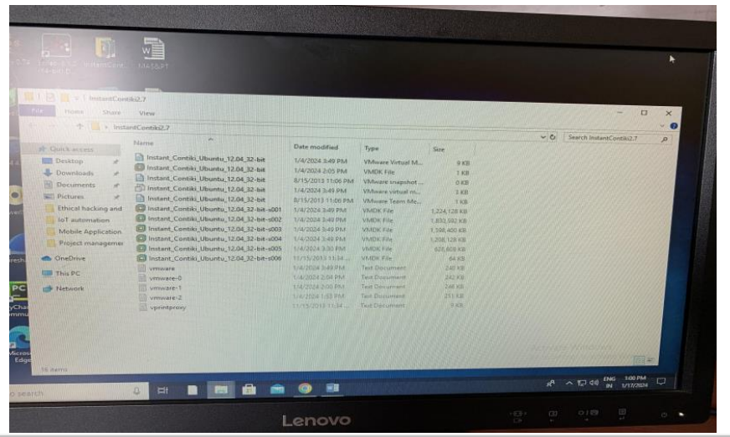

1. Open instant_ Contiki in VMware and click on Power on this virtual machine.

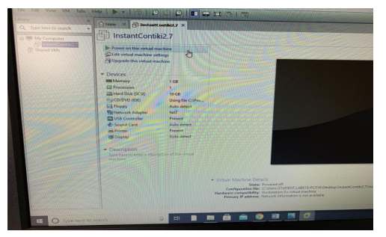

1. Window opened and ask to write password. Password is User. Then open Cooja simulator window.

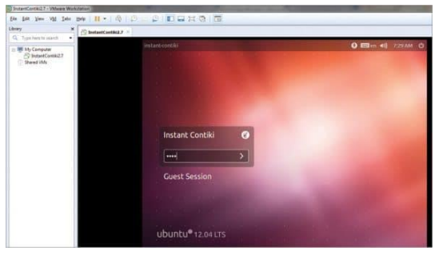

1. Start a new simulation.

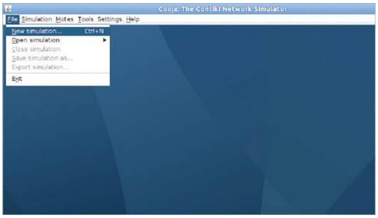

1. Add Motes and make the connection.

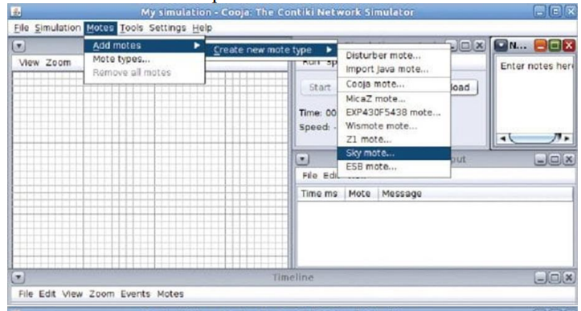

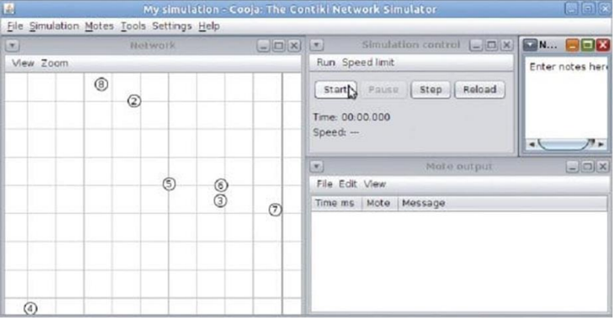

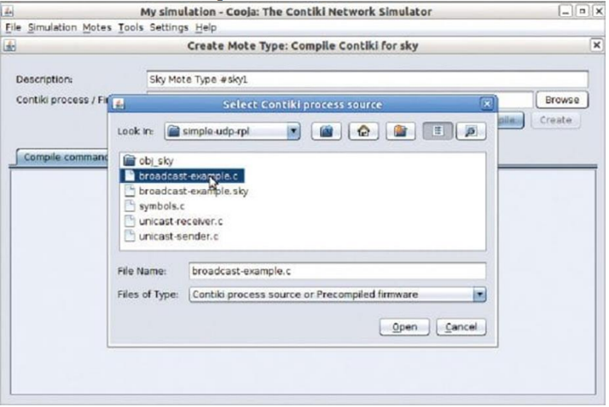

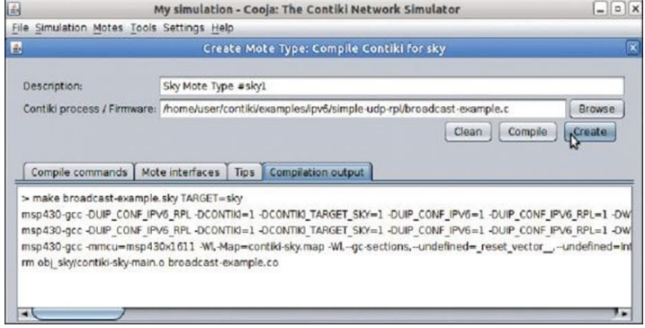

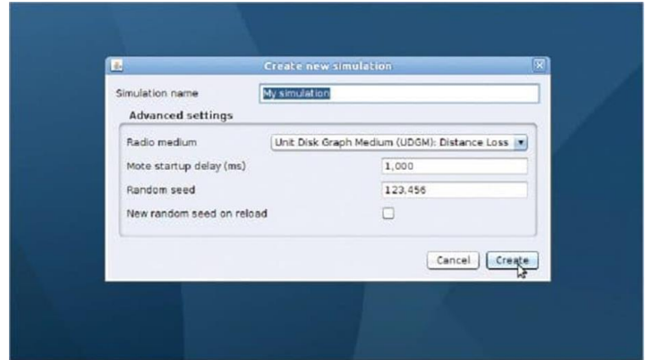

1. Connection Established.

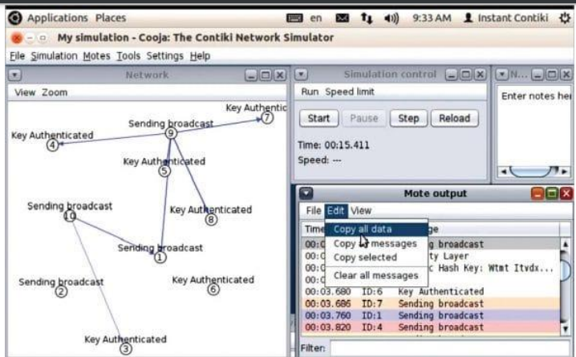

⚫**Benefits of Cooja simulator**:

It allows the simulation of different levels from physical to application layer, and also allows the emulation of the hardware of a set of sensor nodes. Wireless Sensor Networks (WSNs) can be deployed using available hardware and software. The Contiki is an operative system compatible with a wide range of WSN hardware.

***Major Advantages in Cooja IOT Simulator***

* Communicate with the Nodes from the Host Machine
* It is used to connect the host machines and simulated nodes along with the web interface
* Capture Network Packets and View in WireShark
* The exploration of mesh network leads to capture the packets in the nodes and settle them as pcap file then it is analyzed by the Wireshark
* Timeline View of Events
* The timeline takes place in all the selected nodes and it is verified by the internal LEDs blink
* Emulation of 10 Metre Grid of Physical Environment
* The characterizes are placed in the nodes of wireless signal strength autonomously when the simulation takes place in the physical environment at 10-meter grid.

⚫ **Conclusion:**

The text emphasizes the significance of using IoT COOJA simulators for studying and demonstrating real-time applications.

**EXPERMINT: 02**

⚫ **Title**: : CoAP protocol in Contiki OS⚫ **Aim:** To study and simulate CoAP protocol in Contiki OS.

⚫**Theory:**

Contiki is an operating system for networked, memory-constrained systems with a focus on low-power wireless Internet of Things (IoT) devices. Contiki OS has three network stacks: IPv4, IPv6, and Rime. The lIP stack is for IPv4 and IPv6 networking. Rime stack is used for low-power wireless networks using a lightweight protocol stack. The major work is related to network layer as the proposed work mainly focuses on RPL design. Constrained Application Protocol (CoAP) is a specialized Internet application protocol for constrained devices, as defined in RFC 7252. It enables those constrained devices called "nodes" to communicate with the wider Internet using similar protocols.

CoAP a customary client-server IoT protocol. It enables clients to make requests for web transfers as per the need of the hour. On the other hand, it also let supporting servers to respond to arriving requests. In summary, devices’ nodes in the IoT ecosystem are enabled to interact over through CoAP only. CoAP and HTTP follow the same working procedure. However, CoAP attains its functionality via asynchronous transactions (using UDP). It utilizes the POST, GET, PUT, and DELETE calls. That’s the reason why API security is of higher grade while CoAP is active as it is an RPK and PSK-certified protocol.

CoAP is compatible with 4 types of information exchange:

* Acknowledgments confirm the completion or failure of an event.
* Confirmable are the messages that are resent on time out until the confirmation of successful sending doesn’t arrive.
* Reset messages are empty, with confirmable as their nature.
* Non-confirmable information is just sent and has no guarantee of successful delivery. There is no acknowledgment of success either.

⚫**CoAP Architecture:**

The WWW and the constraints ecosystem are the 2 foundational elements of the CoAP protocol architecture. Here, the server monitors and helps in communication happening using CoAP and HTTP while proxy devices bridge the existing gap for these 2 ecosystem, making the communication smoother. CoAP allows HTTP clients (also called CoAP clients here) to talk or exchange data/information with each other within resource constraints. While one tries to understand this architecture, gaining acquaintances with some key terms is crucial:

* Endpoints are the nodes that host have knowledge of;
* Client sends requests and replies to incoming requests;
* Server gets and forwards requests. It also gets and forwards the messages received in response to the requests it had processed.
* Sender creates and sends the original message.
* Recipient gets the information sent by the client or forwarded by the server.

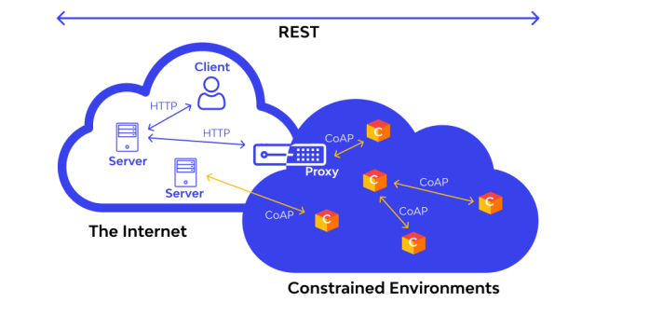

⚫**CoAP Function:**

The key role of CoAP is to act like HTTP wherever restricted devices are a part of communication. While filling the gap of HTTP, it enables devices like actuators and sensors to interact over the internet. The devices, involved in the process, are administered and controlled by considering data as a system’s component. CoAP protocol can operate its functions in an environment having reduced bandwidth and extreme congestion as it consumes reduced power and network bandwidth. Networks featuring intense congestion and constrained connectivity are not ideal conditions for TCP-based protocols to carry out their responsibilities. CoAP comes as a rescuer at this place and supports the wen transfers. Web transfers happening using satellites and covering long distances can be accomplished with full perfection using CoAP. Networks featuring billions of nodes take the help of the CoAP protocol for information exchange. Regardless of the function handled or role played, CoAP promised security of highest grade as DTLS parameters as default security parameter; the counterpart of 128bit RSA keys. Speaking of its deployment, it’s simple and hassle-free. It can be implemented from scratch for a straightforward application. For the application ecosystem where CoAP is not desirable, generic implementations are offered for various platforms. Most of the CoAP implementations are done privately while few are published in open-source libraries like MIT license.

⚫**Key Features of CoAP:**

1. RESTful Architecture: CoAP uses a RESTful (Representational State Transfer) architecture. It follows a set of constraints that allow it to operate efficiently over a large, distributed network. In a RESTful system, data and functionality are considered resources, and these resources are accessed using a standard, uniform interface.
2. Built-In Discovery
3. The CoAP protocol’s built-in discovery mechanism allows devices to discover resources on other devices without requiring any prior knowledge of their existence. This is especially useful in IoT networks, where devices may be constantly joining and leaving the network.
4. Asynchronous Message Exchanges
5. CoAP supports asynchronous message exchanges, which is crucial for IoT networks where devices may not always be connected or available. With asynchronous message exchanges, a device cansend a request to another device and then continue with other tasks without waiting for a response. The response can be processed once it arrives, even if delayed.
6. Optional Reliability with Confirmable Messages
7. CoAP offers optional reliability through the use of confirmable messages. When a device sends a confirmable message, it expects an acknowledgement from the recipient. If no acknowledgement is received within a certain time, the message is retransmitted.

⚫**Advantages to CoAP**:

1. Reduced power requirements
2. It operates over UDP, which requires minimal overhead for communications.
3. It also allows faster wake up times and extended sleepy states.
4. Taken together, this means batteries last longer for IoT devices.

⚫**CoAP vs. MQTT:**

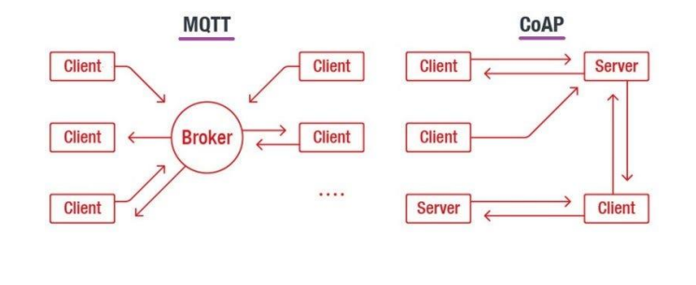

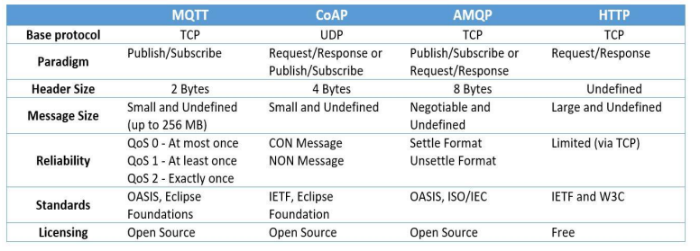

⚫**Procedure:**

1. Start a new simulation.
2. Open and compile broadcast example from Contiki process source.

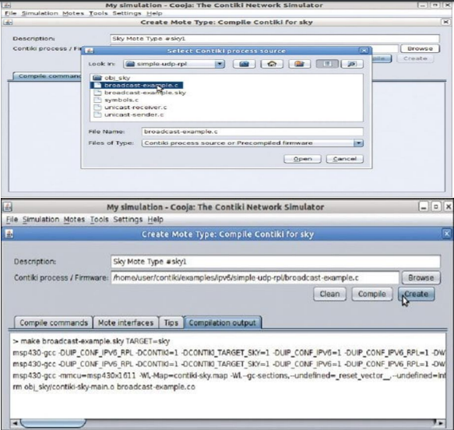

3) Add Motes and make the connection

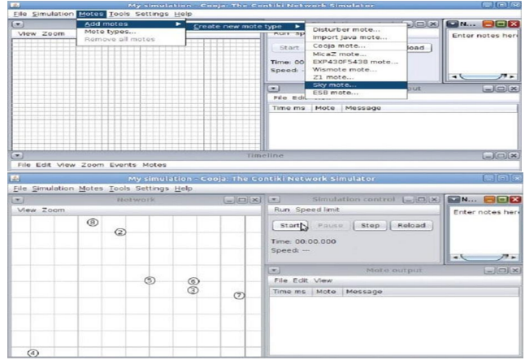

4) Connection Established

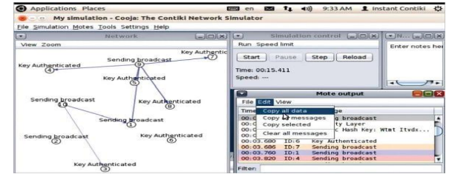

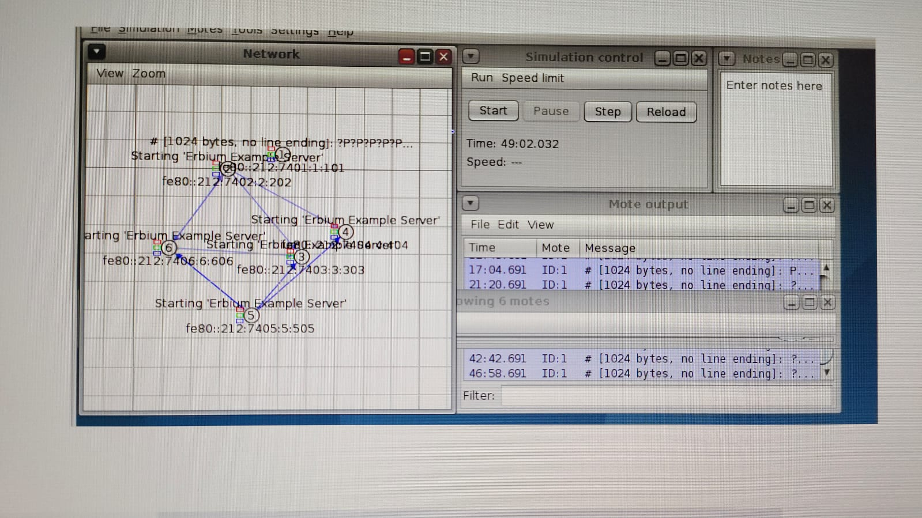

⚫**Result & Conclusion:**

The study and simulation of CoAP in Contiki OS contribute to the broader exploration of IoT communication protocols, emphasizing the practical implementation and adaptability of CoAP for resource-constrained devices. This knowledge is valuable for developers and researchers working on IoT applications and protocols.

**EXPERMINT: 03**

⚫ **Title**: IOT NodeRed simulator⚫ **Aim:** Real time data acquisition and transmission using NodeRed simulator.

⚫**Theory:**

⚫**NodeRed:**

Node-RED is a [flow-based](https://en.wikipedia.org/wiki/Flow-based_programming), [low-code](https://en.wikipedia.org/wiki/Low-code_development_platform) development tool for [visual programming](https://en.wikipedia.org/wiki/Visual_programming_language) developed originally by [IBM](https://en.wikipedia.org/wiki/IBM) for wiring together hardware devices, [APIs](https://en.wikipedia.org/wiki/Application_programming_interface) and [online services](https://en.wikipedia.org/wiki/Online_services) as part of the [Internet of Things](https://en.wikipedia.org/wiki/Internet_of_Things).

Node-RED provides a [web browser](https://en.wikipedia.org/wiki/Web_browser)-based flow editor, which can be used to create [JavaScript](https://en.wikipedia.org/wiki/JavaScript) functions. Elements of applications can be saved or shared for re-use. The runtime is built on [Node.js](https://en.wikipedia.org/wiki/Node.js). The flows created in Node-RED are stored using [JSON](https://en.wikipedia.org/wiki/JSON). Since version 0.14, [MQTT](https://en.wikipedia.org/wiki/MQTT) nodes can make properly configured [TLS](https://en.wikipedia.org/wiki/Transport_Layer_Security) connections.

⚫**MQTT stands for Message Queuing Telemetry Transport.**

MQTT stands for Message Queuing Telemetry Transport. It is an extremely simple and lightweight messaging protocol (subscribe and publish) designed for limited devices and networks with high latency, low bandwidth or unreliable networks. Its design principles are designed to reduce the network bandwidth and resource requirements of devices and ensure security of supply. In addition, these principles are advantageous for M2M (machine-to-machine) or IoT devices because battery performance and bandwidth are very important.

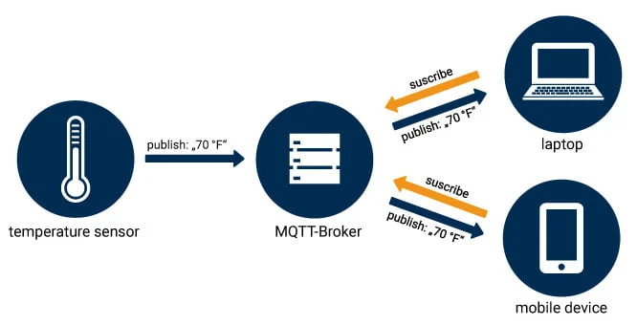

The MQTT broker is the center of every Publish / Subscribe protocol. Depending on the implementation, a broker can manage up to thousands of simultaneously connected MQTT clients. The broker is responsible for receiving all messages, filtering the messages, determining who subscribed to each message and sending the message to those subscribed clients. The Broker also holds the sessions of all persistent clients, including subscriptions and missed messages. Another task of the Broker is the authentication and authorization of clients. Usually the broker is extensible, which facilitates custom authentication, authorization and integration with backend systems. Integration is especially important, because the Broker is often the component directly exposed on the Internet, serves many clients and has to forward messages to downstream analysis and processing systems.

⚫**Features of MQTT**

There are various features of MQTT which are as follows:

* It is a machine-to-machine protocol, i.e., it provides communication among the devices.
* It is produced as a simple and lightweight messaging protocol that supports a publish/subscribe system to transfer the data between the user and the server.
* It does not require that both the user and the server create a connection at an equal time.
* It provides quicker data transmission, like how Whatsapp/messenger supports a quicker delivery.
* It enables the users to subscribe to the definite selection of topics to receive the data they are viewing for.
* It can distribute data more effectively.
* It can increase scalability.
* It is used to lower network bandwidth consumption dramatically

⚫**Advantages of MQTT Protocol:**

Following are the benefits or advantages of MQTT protocol:

* The MQTT protocol payload can carry any type of data such as binary, ascii text etc. The receiver need to interpret and decode as per format used by the transmitter. Hence MQTT is packet agnostic.
* It uses packet of low size and hence can be used for low bandwidth applications.
* It offers lower battery power consumption.
* It is reliable protocol as it uses QoS options to provide guaranteed delivery.
* Due to its publish/subscribe model, It is scalable.
* It offers de-coupled design as it is easy to decouple the device and server.

⚫***Here's a general guide on how to simulate data or interact with simulated devices using Node-RED:***

**1. Install Node-RED:**

* Ensure Node-RED is installed on your system. You can install it globally using npm:

bashCopy code

npm install -g node-red

**2. Start Node-RED:**

* Start Node-RED by running the following command:

bashCopy code

node-red

* Access the Node-RED editor by opening your web browser and navigating to **http://localhost:1880**.

**3. Install Necessary Nodes:**

* Depending on your simulation requirements, you might need to install additional nodes. For example, for MQTT communication or other IoT protocols.

**4. Create a Flow:**

* Design a flow in Node-RED by dragging and dropping nodes onto the workspace.

**5. Simulate Data:**

* Use inject nodes or function nodes to simulate data. Inject nodes allow you to inject messages at specific intervals.

**6. Connect to External Simulators:**

* If you're working with external simulators, connect Node-RED to them using appropriate nodes. For instance, MQTT nodes can connect to an MQTT broker that is part of your simulation.

**7. Visualize Data (Optional):**

* Use Dashboard nodes to create visualizations and dashboards for the simulated data.

**8. Deploy and Monitor:**

* Deploy your flow, and monitor the Node-RED debug console for any messages or errors.

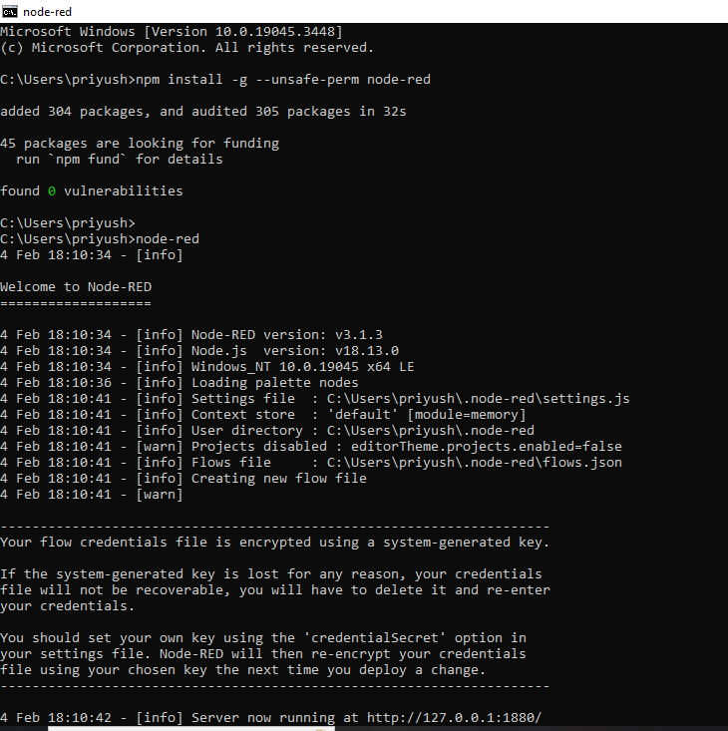

⚫**Step Real time data acquisition and transmission using NodeRed simulator.**

1. **Install Necessary Nodes:**

* In Node-RED, install nodes that are necessary for your project, such as MQTT nodes for communication.

2. **Create Data Source:**

* Simulate or connect a data source. This could be a simulated sensor generating data or an actual IoT device.

3. **Node-RED Flow Design:**

* Design a flow in Node-RED that includes nodes for data acquisition, processing, and transmission.

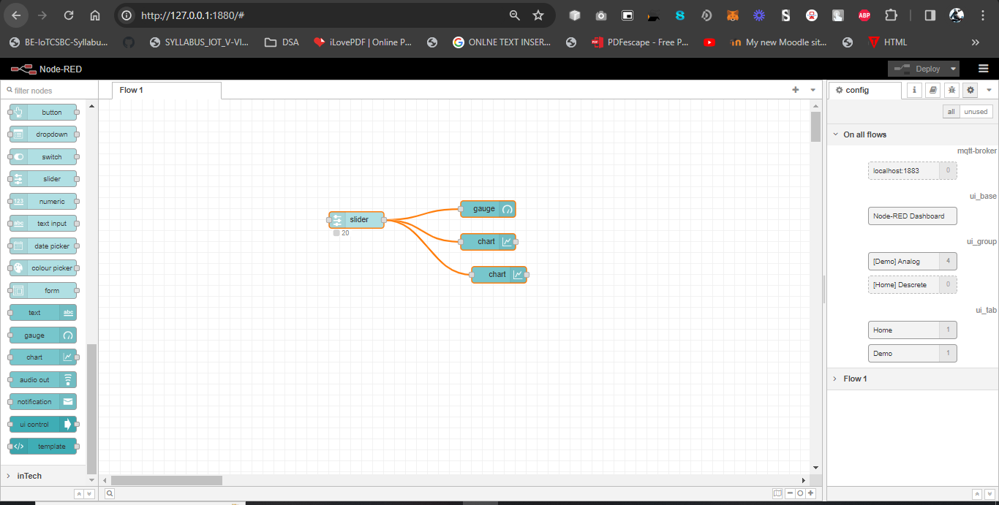

4. **Data Acquisition:**

* Use appropriate nodes (e.g., inject nodes, function nodes) to acquire real-time data from the source.

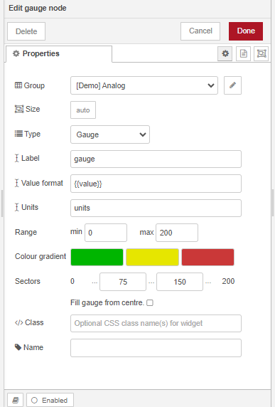

5. **Data Processing:**

* Implement any required data processing within Node-RED. This could include filtering, formatting, or aggregating data.

6. **Real-time Transmission:**

* Use nodes like MQTT or WebSocket nodes to transmit real-time data to a destination.

7. **Integration with External Services:**

* If necessary, integrate Node-RED with external services or databases to store or further process the data.

8. **Dashboard (Optional):**

* Create a real-time dashboard using Node-RED Dashboard nodes to visualize the acquired data.

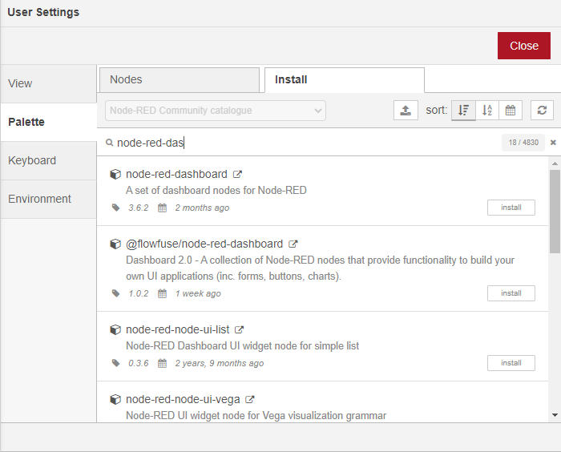

9. **Testing:**

* Test the entire flow by deploying it in Node-RED and observing the real-time data acquisition and transmission.

⚫**Result**:

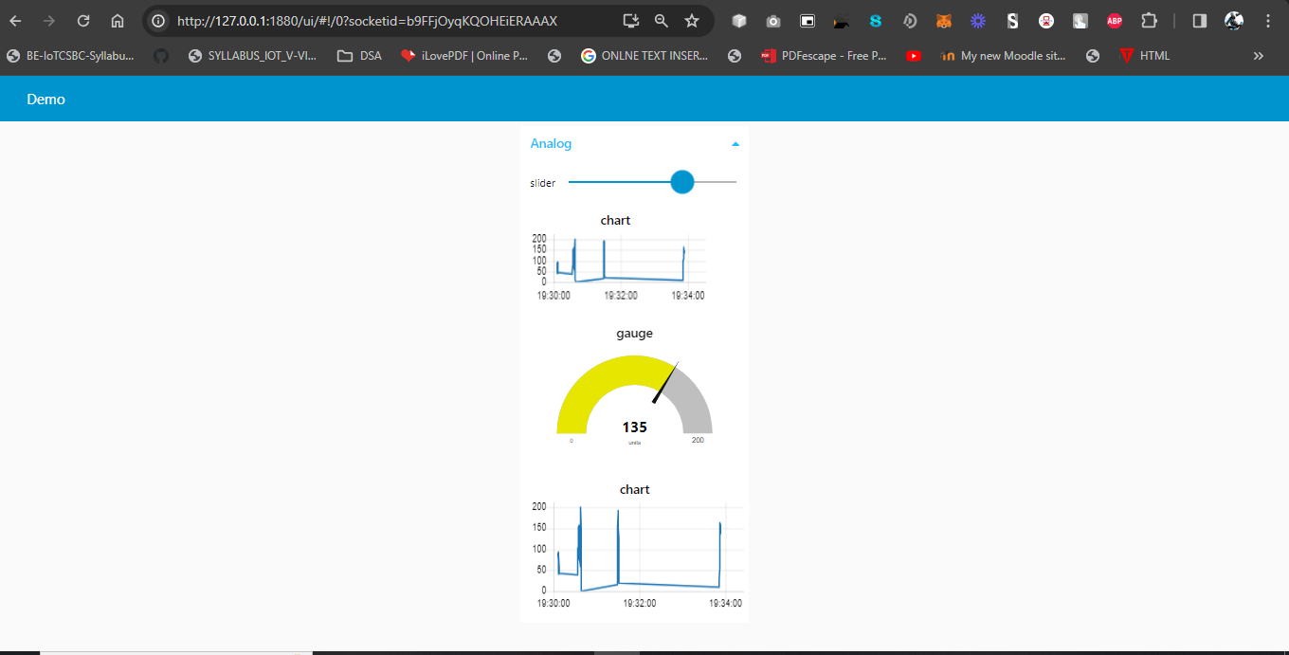

⚫**Conclusion:**

Implementing real-time data acquisition and transmission using Node-RED provides a flexible and visual approach to building IoT applications. It allows you to quickly prototype and iterate on your project, making it easier to adapt to changing requirements.

**EXPERMINT: 04**

⚫ **Title**: MySQL database on Raspberry Pi

⚫ **Aim:** To install MySQL database on Raspberry Pi and perform basic SQL queries.

⚫**Theory:**

MySQL is a real-time relational database management system that organizes data into one or more data tables. The data stored in the tables may be related to each other, thus, ensuring an organized data structure. This database management system is mostly used in creating web servers or accessing another server and is an ideal choice for both small and large-scale applications. It can handle the most expensive and powerful database packages and is simple to use on any system.

⚫**Procedure**:

1) How to Setup MySQL Database on Raspberry Pi

The MariaDB server is introduced by MySQL developers as a drop-in replacement for the MySQL server.

Therefore, the MySQL server is no longer available in the Raspberry Pi repository.

* 1. To install and setup MySQL (MariaDB) database, follow the below-mentioned steps:

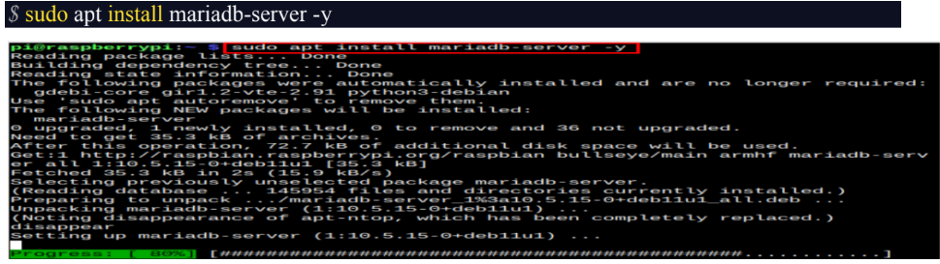

1.2) After completing the installation, you must secure your MySQL database from the

following command:$ sudo mysql_secure_installation.

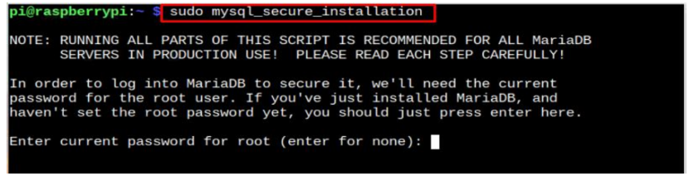

1.3) Enter your system password to configure MySQL database setup. Then choose the default option “n” to stay with the root account instead of switching to unix_socket.

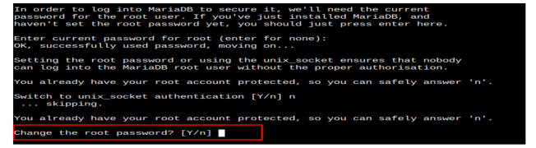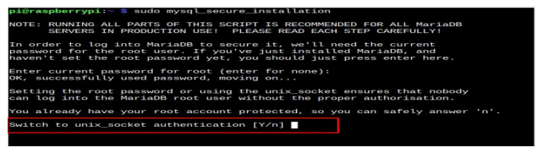1.4) Enter “n” to stick with the default root password.

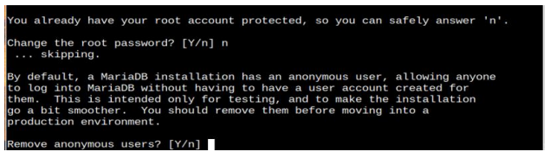1.5) Remove the anonymous users by entering “Y”.

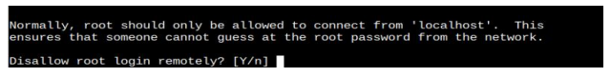You can disable the root login remotely or enable it according to your choice. If write “n”.

1.6) Enter “Y” to remove the test database or you can reply with “n” too.

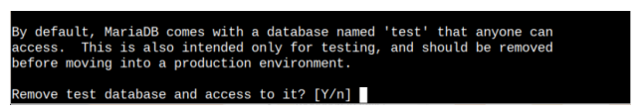

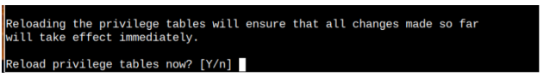1.7) Reload the privilege tables by entering “Y” to make the changes.

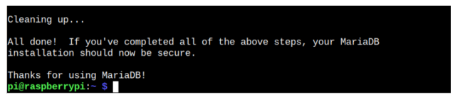This completes the MySQL database configuration.

2) Create a Database Using MySQL

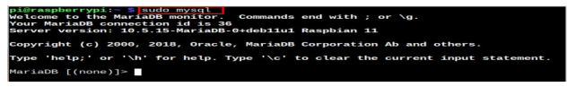2.1) Now, to start creating your first database through MySQL, first, execute the following command tolog in to MySQL. $ sudo mysql.

2.2) Then create a database using the following syntax:

CREATE DATABASE <database_name>;

For example, the name of the database is “sqldatabase”:

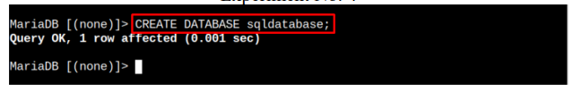CREATE DATABASE sqldatabase;

2.3) Create a username and password for your database and then grant all privileges to your database

using the following syntax: GRANT ALL PRIVILEGES ON <database_name>.* TO '<username>'@'localhost' IDENTIFIED BY '<password>';

2.4) Replace the <username> and <password> in the above command.

Finalize the changes by flushing the privilege table through the following command:

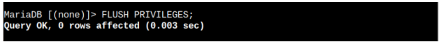FLUSH PRIVILEGES;

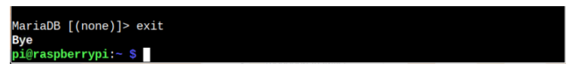2.5) Exit to the database through the “exit” command.

This completes the MySQL database creation on the Raspberry Pi system.

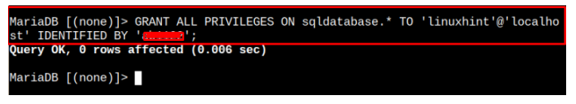

⚫**Conclusion and Result:**

The combination of MySQL database installation on Raspberry Pi and basic SQL queries for data analysis offers a powerful and accessible solution for managing and analyzing data collected by Raspberry Pi-based projects. Whether for educational purposes, hobbyist projects, or professional applications, this setup provides a versatile and scalable platform for exploring the potential of data-driven computing on the Raspberry Pi ecosystem.

**EXPERMINT: 05**

⚫ **Title**: Esp32 and ThingSpeak.

⚫ **Aim:** To study and implement a program on ESP32/NodeMCU to push and retrieve the data from any cloud like Thingspeak, Thingsboard, AWS, Azure etc.

⚫**Theory:**

**ESP32**

ESP32 is a series of feature-rich MCU with integrated Wi-Fi and Bluetooth connectivity for a wide range of applications. Espressif Systems, China, produce it.ESP32 is cheap and nearly ten times faster than Arduino Uno and is a 32-bit versatile device. Developers of ESP32 IC made a small module board with edge castellations. One popular version of such a module board is called ESP-WROOM-32. It is a dual-core, 32-bit microcontroller unit, and all the cores can be controlled individually. It has integrated Wi-Fi, Bluetooth, and Bluetooth Low Energy withmultiple digital and analog I/O pins.

**Why ESP32 is better than Raspberry Pi ?**

The ESP32 and Raspberry Pi are both microcontrollers that can handle IoT tasks. However, the ESP32 is a better fit for wireless communication tasks, such as building a smart thermostat or weather monitoring system.

**Here are some other advantages of the ESP32:**

* Compatible with Arduino code
* Integrated Bluetooth, WiFi, and camera
* MicroPython and Arduino IDE support
* Larger modules than the Pico chip
* Ultra-low consumption functions

**Procedure:**

**Step 1**: Firstly you have to download and install **Arduino IDE** software which you can download from https://www.arduino.cc/en/Main/Software for free. If you have already installed in your PC then make sure that it is latest version of IDE as older version doesn’t include ESP32 board.

**Step 2**: After installing, open IDE and go to Files -> Preferences and open preference window and see the “**Additional Boards Manager URL’s**” as:

**Step 3:** This box maybe empty or contain some other URL if you have used it previously for ESP8266. You just have to paste below URL into this box if the box contains already another URL then paste it by separating another URL using comma(,).

<https://dl.espressif.com/dl/package_esp32_index.json>

**Step 4:** After pasting the given URL my window looks like this as I already used ESP82666, Now press OK and the window will disappear.

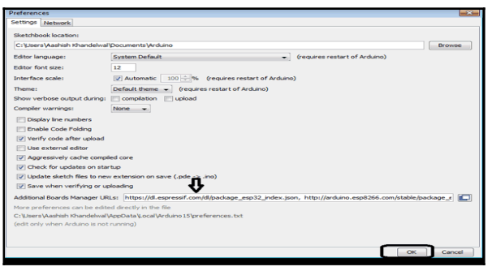

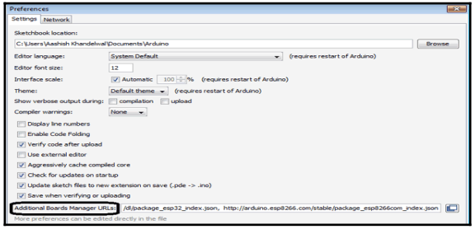 Step 5: Now go to Tools-> Board-> Board Manager and search for ESP32 and press install, it will take some time to install make sure that you have internet connection while installing after installing your window looks like this:

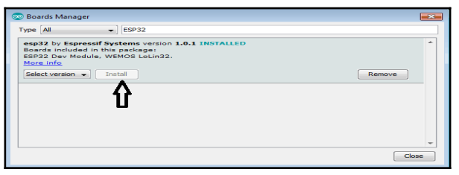

After this close the window of board manager and your IDE is ready to work with ESP32.

**ThingSpeak Setup for ESP32**

ThingSpeak is a free web service which helps us in IoT based projects. By using ThingSpeak server, we can monitor our data over the internet using the API and channels provided by ThingSpeak. In this section I am explaining about how to send sensor data of ESP32 to ThingSpeak server. For this you have to follow following steps:

* 1. Firstly go to https://thingspeak.com/ and create an account and sign in to this server.
  2. After signing in you will find below window in which number of channels are listed in this go to New channel.

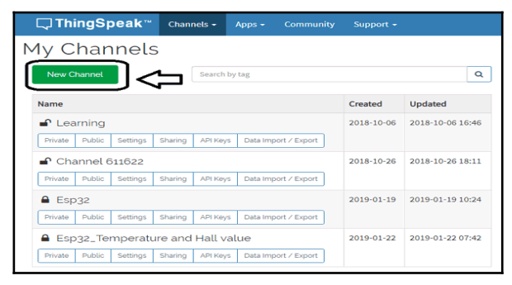

3. After clicking on New Channel you will find a window in which you have to enter some details about the channel, in this project we want to analyze temperature and Hall sensor value of ESP32 so you will require 2 fields. So enter the details as shown and save the channel.

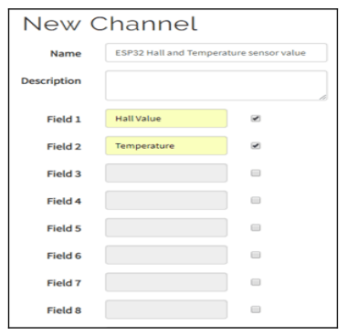

4. After saving of channel you will find channel stats window showing details about your channels.

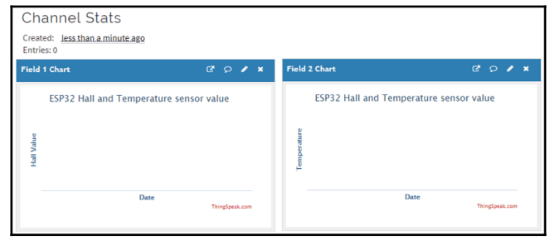

5. Now go to API key menu which shows you Write API keys and Read API key, Copy Write API key as you will required this API during programming of ESP32. 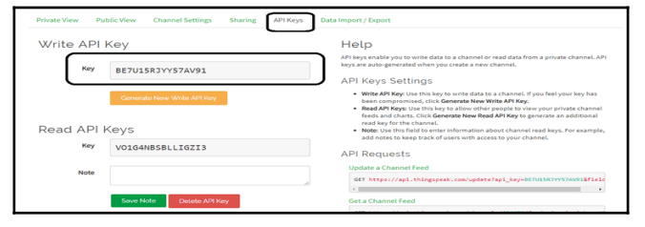

Program code:

//ESP32 with Thingspeak

#include <WiFi.h>

#include <HTTPClient.h>

#include "DHT.h"

#define DHTPIN 5

#define DHTTYPE DHT11

DHT dht(DHTPIN, DHTTYPE);

const char* ssid = "Test"; // replace with your wifi ssid and password

const char* password = "12345678";

const char* serverName = "http://api.thingspeak.com/update";

String apiKey = "DKB0DG7AEAPIQKHC"; // enter your api key

void setup() {

Serial.begin(115200);

WiFi.begin(ssid, password);

dht.begin();

Serial.println("Connecting");

while(WiFi.status() != WL_CONNECTED)

{

delay(500);

Serial.print(".");

}

Serial.println("");

Serial.print("Connected to WiFi network with IP Address: ");

Serial.println(WiFi.localIP());

}

void loop() {

if(WiFi.status()== WL_CONNECTED){

WiFiClient client;

HTTPClient http;

delay(10000);

float h = dht.readHumidity();

float t = dht.readTemperature();

if (isnan(t) || isnan(h)) {

Serial.println(F("Failed to read from DHT sensor!"));

return;

}

http.begin(client, serverName);

http.addHeader("Content-Type", "application/x-www-form-urlencoded");

String httpRequestData = "api_key=" + apiKey + "&field1=" + String(t) + "&field2=" +

String(h);

int httpResponseCode = http.POST(httpRequestData);

Serial.print("HTTP Response code: ");

Serial.println(httpResponseCode);

http.end();

} else {

Serial.println("WiFi Disconnected");

}}

Now to upload the program in ESP32 we have to follow some steps as follows:

* 1. Open your Arduino IDE and create a new file and save it where you want.
  2. Copy the given code.
  3. Now go to Tools--> Board--> ESP32 Dev Module.

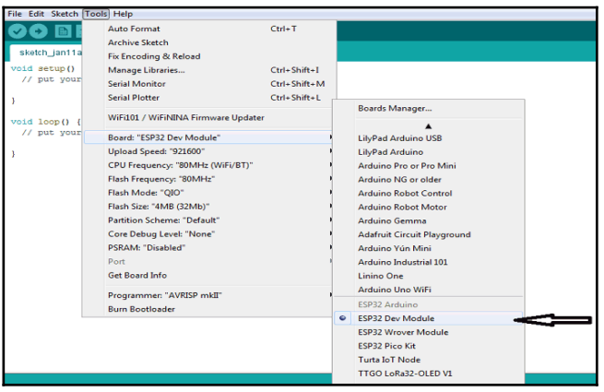

* 1. Now go to Tools-->Port and select port to which your ESP32 is connected.
  2. Now click on upload to upload the code.
  3. After complete uploading you will find message like this in your output console.

**Result:**

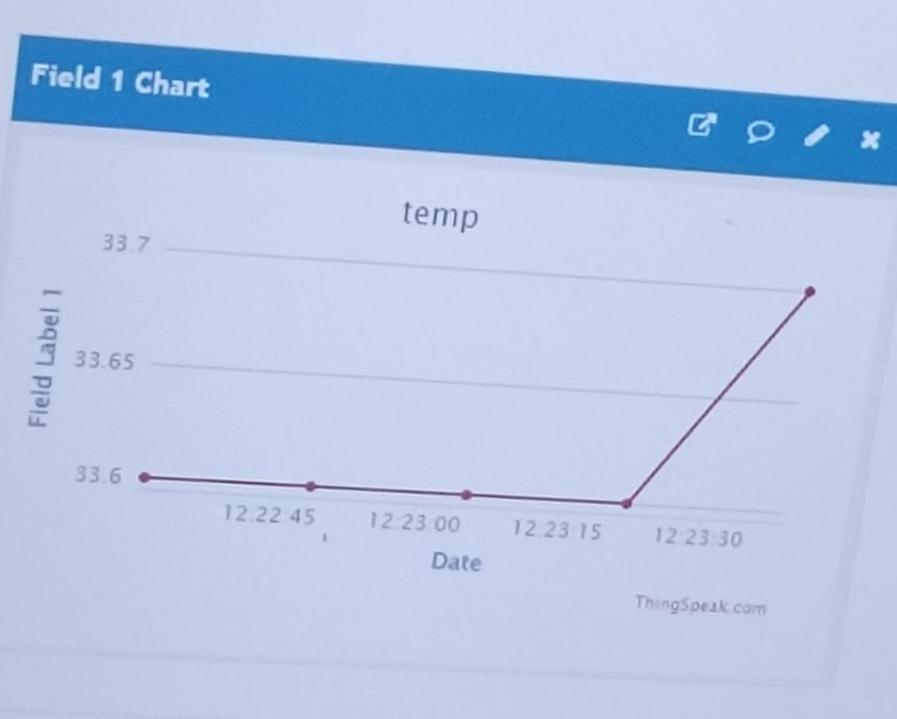 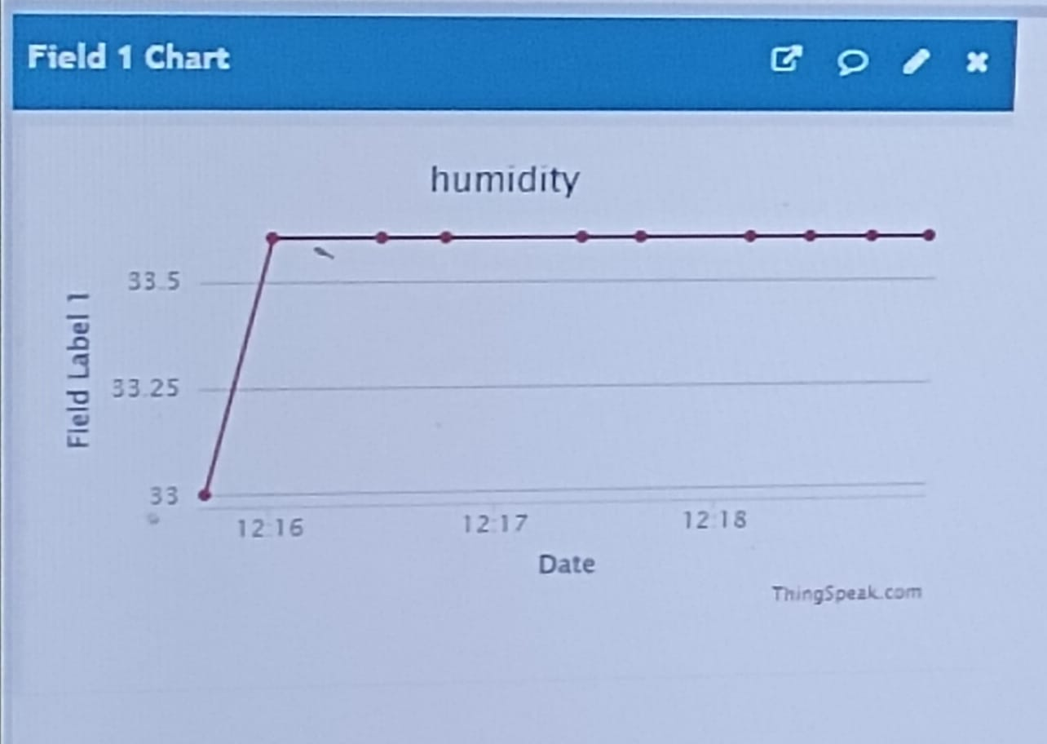

**Conclusion:**

The study and implementation of a program on ESP32/NodeMCU to push and retrieve data from cloud platforms represent a significant step towards building scalable, efficient, and intelligent IoT solutions. By leveraging the capabilities of cloud computing, we can unlock new opportunities for innovation, collaboration, and value creation in the rapidly evolving IoT landscape.

**EXPERMINT: 06**

⚫ **Title**: Programmable Logic Controller.

⚫ **Aim:** Introduction to PLC and Introduction to digital I/O interface to PLC.

⚫**Theory:**

**Introduction**

A programmable logic controller (PLC) is a device which is used to provide control for an automated process. Using PLC's to achieve automation has many advantages like:

1. Consistency in manufacturing can be easily achieved.
2. Complete control of the manufacturing process can be achieved.
3. Accuracy and quality can be improved.
4. Productivity can be improved.
5. Makes it easy to work in difficult or hazardous environment.

**Basic block diagram:**

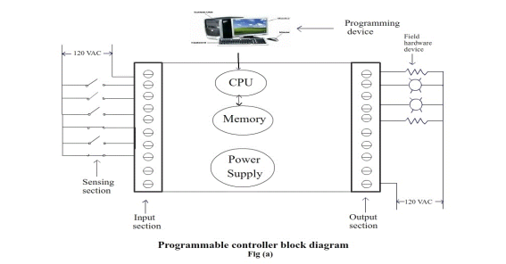

A PLC has following sections and each section has unique job to perform.

The sensing section :

This section consists of limit switches, photoelectric sensors, push buttons etc. These incoming

hardware devices provides input signal to the PLC. These devices are also called as field input

devices. The term “field input " is used because this device provides incoming signals that are

tangible items that you physically connect to PLC.

Input section :

This section is majorly divided into 2 parts:

First, the physical screw terminals, where incoming signal (i.e. input), from the field input devices (e.g. limit switch) are connected to the PLC. The second portion of them input section is the PLC's internal conversion electronics. This section converts and isolates the high-voltage input level from field input devices. High-voltage signals from field input devices are converted to +5 volts direct current (VDC) for a valid ON input signal, and a 0 VDC for a valid OFF input signal. Incoming signal conversion and isolation is necessary because microprocessor components operate on +5 VDC, whereas an input signal may be of 24 VDC, 120 volts alternating current (VAC), or 220 VDC. If 120 VAC signal is inputted, for example, into 5 VDC, circuit will quickly destroy your PLC.

**Controller**:

The controller is also known as central processing unit (CPU), or simply as the processor. Central processing unit controls or supervises the entire process. The central processing unit solves the user program and apparently updates the status of the outputs.

**Programmer**:

The programmer is a device used by the programmer or operator to enter or edit program instructions or data. The programmer can be handheld unit, a personal computer, or an industrial computer programming terminal.

**Output section:**

The ON or OFF status of the inputs are read and the information is used to solve the user ladder program and the updated signals is sent to the output section. The output section is simply a series of switches, one for each output point, that are controlled by CPU and are used to turn output field devices ON or OFF.

**Field hardware devices:**

The devices that are controlled by the PLC's output section screw terminals are the field hardware devices.

**Fixed and modular PLC hardware:**

There are two types of physical configurations, fixed and modular. In a fixed PLC, all of its components like, the input section, power supply, CPU and associated memory and output section - is built into one self - contained unit. All the input and output screw terminals are built into the PLC package and are fixed, which cannot be moved i.e. not removable. This type of PLC is also called as a packaged controller. The modular PLC comes as separate pieces. All the parts of modular PLC are purchased separately i.e. piece by piece. It’s like customizing , we may have 2 or 3 power supplies to choose from , a handful of different processors(CPU's) , many separate input modules , many separate output modules and a selection of assemblies , called racks , chassis , or baseplates to hold the pieces together.

**How does a PLC work?**

Microprocessor is the heart of any computer, it is also called as processor, or CPU. The central processing unit supervises system control through the user program. After reading the input signal, the CPU follows the instructions, that a programmer or operator has stored in the PLC's memory. Depending upon the result of the solved program, the field control devices or outputs are turned ON or OFF. When the PLC is running and following the programmer's instructions, it is called as solving the program.

How do PLC's know what they are supposed to do?

A PLC just follows the instructions stored in memory. Each instruction given by the programmer is placed in PLC memory in ascending order. A list of instruction is called as the user ladder program.

**How does a PLC work?**

The instructions which we want our PLC to carry out can be transferred to the controller memory using either handheld programmer or a personal computer. The first step is to develop the user ladder program. Once the user ladder program is verified for correctness, the next step is to download the program into the processor's memory. The process of transferring the user defined PLC program from personal computer's memory into PLC memory is called as downloading the program. But before downloading the user program, the processor must be in program mode. Now, if all the inputs and outputs signals are wired to the correct screw terminals, the processor can be put in run mode. In run mode, the program will continuously run and solve the programmed instructions. The process of solving the programmed instruction is sometime called as solving the logic. This constant running of the program in a PLC is called as scanning.

**NOTE**:

When the PLC is switched into the program mode, all outputs from the PLC are forced OFF regardless of their rung logic status, and the ladder I/O scan sequence is halted. Run mode is used to execute the user program. Input devices are monitored and output devices are energized accordingly. Test mode is used to operate or monitor the user program without energizing any outputs. Remote mode allows the PLC to be remotely changed between program and run mode by a personal computer connected to the PLC processor.

**INTRODUCTION TO DIGITAL PLC INTERFACE:**

**Introduction**:

There are 16 point, 8 point and 32 point input module. As, an example, Fig (a), let us take a standard input module with 16 points. Each 16 point input module corresponds to one 16-bit word of data. Also, each input point corresponds to 1 bit in the 16- bit word associated with the input module.

**Note**:- A bit position cannot be empty, there is either 1 or 0 value in each position all the times.

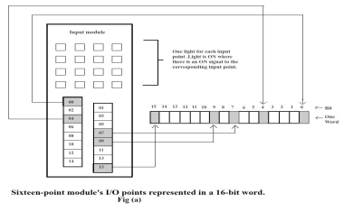

In the above figure, input three is a closed switch, which is going into the input screw terminal 3. As we can see the switch is closed, an ON (1) signal is sent to the input word, in bit position 3. Also from the figure, we can see input 4 is an open switch going into the input screw terminal 4. Since the switch is open, an OFF (0) signal is transferred to the input word, in bit position 4.

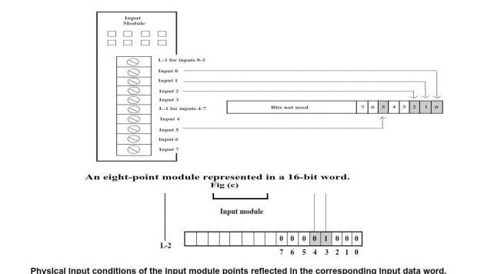

Even eight - point input modules are also available. In these modules, only the lower eight bits of the input word are used**.**

**Input status file**: Input status file is a cluster of words in memory, that are organized to store input data. The data which is stored in the input status file is used by the CPU when the program is solved. Each I/Omodule in a chassis is assigned a specific word in the input status file. Each screw terminal in an input module corresponds to one memory location in the input status file, which can be used to store ON (1) or OFF (0) status of the connected field input devices.

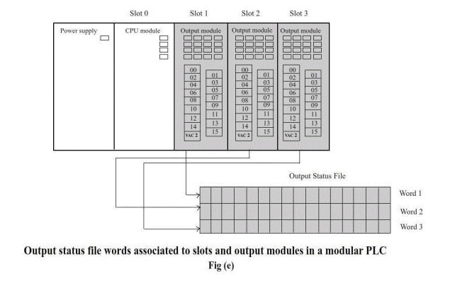

The above figure represents a four -slot modular PLC, which contains a power supply, a CPU module, and three output modules. Here also each slot of the chassis has a corresponding number. The CPU is in slot zero, while output modules reside in slots one through four. The slot number corresponding to a particular output module identifies in which 16-bit word the output status file will store that particular module's ON or OFF output data.

After solving user ladder program, the CPU sends each 16-bit output status file word to its associated output module by way of backplane. Each output module takes the low-voltage ON or OFF signal, which is represented as 0 or 1 bit in the 16-bit word, isolates it, and turns on or turns off the associated output's switching device. Each output module has one switching device for each output point. These switching devices may be small mechanical relays, as shown in fig (f), or solid state devices. The output status file bits electrical signal is sent from the status file to power the relay coil output three's relay output point.

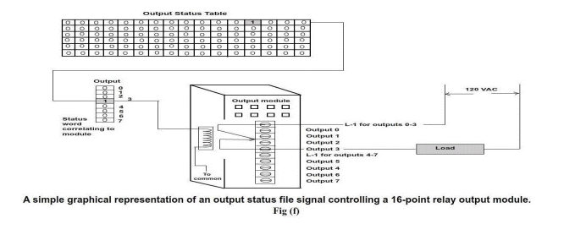

Fig (d) and fig (e) illustrated PLC's with either all input or all output modules. These examples were created to help you understand how status file words correlate with input and output modules. Actual applications will have a mix of input and output modules in the same PLC chassis. One of the major advantages of a modular PLC is the ability to place input and output modules in the selected chassis in the input or output designation required for a specific application.

For example, let us take a seven slot chassis. Here, CPU is placed in slot zero and then, you are free to place any mix of input and output modules you need in the remaining six slots.

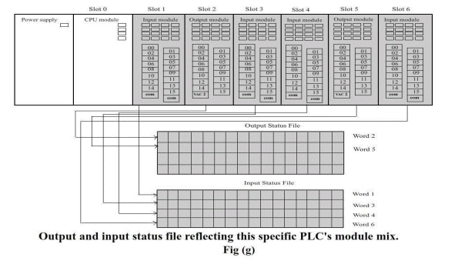

Fig (g) shows a seven - slot chassis with input modules in slot 1,3,4 and 6 and , output modules in slot 2 and 5 .Each input modules will have an associated word with the same input data file number as the slot in which resides . In a similar manner, each output module will have an associated word in the output status file with the same data file word number as the slot in which it resides. Theses status files are two separate data files. Although they are stored in PLC's memory, they are located in predefined, separate areas used strictly for the storage of either input or output status data.

Notice the gaps in both the input status file's input and output status word sequence. There are no input status words reserved for non - existent slots 2 or 5, not output status words 1, 3,4 or 6.

**Sixteen point I/O modules with decimal addressing**:

A typical PLC addressing is dependent on the module type and slot position in which the module resides in the chassis. In order to explain, consider fig (g). The component of each screw terminal’s address consists of the slot number, the screw terminal number, and a designation as to whether the I/O point is an input or output.

If a specific screw terminal is input, we begin its address with an I. If a particular screw terminal is an output, we begin its address with an O. The next thing we need to identify is what slot the module is in. The input module in slot one will be identified as I:1 , the output module in slot two is O:2 , the input module in slot three is identified as I:3.

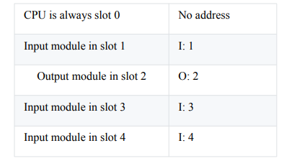

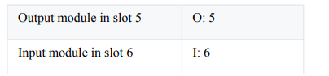

Each screw terminal of a 16-point module is identified as 0 through 15, decimal.

Table 1: Addressing structure format

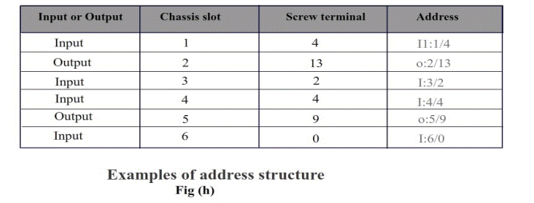

Address format consists of three parts, see figure below. [Fig (i)]

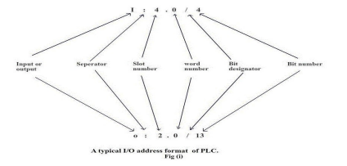

Part 1: I for input, or O for output, and a colon to separate the module type from the slot.

Part 2: The module slot number.

Part 3: The dot signifies a word follows. This is the word number. If using an 8 or 16 point module, only one word is necessary. This is the first word 0. When an 8 or 16 point module, the word number is optional.

Part 4: The slash identifies that a bit follows.

This is the bit or screw terminal number.

Address format = Input or Output: slot / Screw terminal

**I/O interaction with the input and output status files:**

Every PLC manufacturer has its own addressing rules. Let us take a typical 16-bit PLC for our explanation.

**Modular I/O addressing and input and output status file:**

Here in our example, PLC is a 16-bit PLC, therefore data is formatted into a 16-bit words. If we use a 16 - point input module, one word of memory contains enough bits for each input screw terminal. However, if we use a 32-point input module, a 16- bit word only contains enough bits for half of the input points. As a result, two words will be necessary to represent 32 input points. For our explanation, referring to fig(g), let’s assume our modular PLC has the following input and output modules.

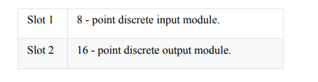

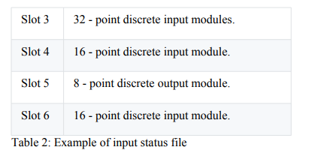

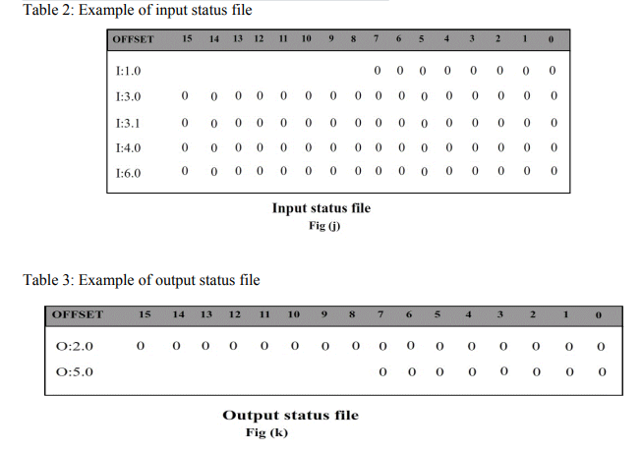

Few observations:

In slot 3, 2 input words are assigned to the 32 - point input module. The first word is I: 3.0 and I: 3.1 is the second word. The lower 16 input addresses, screw terminals 0 through 15, are in the first word. These addresses are I:3.0 / bits 0 through 15. For example: I: 3. 0 / 0 is input module in slot 3, bit or screw terminal 0. I: 3. 0 / 5 is input module in slot 3, bit or screw terminal 5. The addresses for the upper 16 inputs on 32-point module are as follows:

I: 3. 1 / 0 is input module in slot 3, bit or screw terminal 16. Since the lower 16 - bit word contains input points 0 through 15, the second word contains screw terminals or input points 16 through 31.

Remember, the second word is I: 3. 1, so the first bit is I: 3 .1 / 0, or input point 16.

I: 3 .1 / 1 is the input module in slot 3, bit or screw terminal 17.

I: 3 .1 / 2 is the input module in slot 3, bit or screw terminal 18.

Fixed I/O addressing : In fixed PLC manufactured by various companies, the CPU is residing in slot zero, also all I/O screw terminals must also be in slot zero.

The addressing for a fixed PLC is as follows:

* I: 0 / 3 for input screw terminal 3.
* I: 0 / 8 for input screw terminal 8.
* O: 0 / 7 for output screw terminal 7.
* O: 0 / 0 for output screw terminal 0.

**Conclusion:**

The introduction to Programmable Logic Controllers (PLCs) and Digital Input/Output (I/O) interfaces serves as a fundamental stepping stone into the world of industrial automation and control systems. PLCs offer a versatile and robust solution for automating processes across various industries, providing flexibility, reliability, and ease of programming.

**EXPERMINT: 07**

⚫ **Title**: Programmable Logical Controller application of IIoT.

⚫ **Aim:** To study PLC basics, programming elements and their operation for Ladder Diagram in IIoT.

⚫**Theory:**

1) Introduction to Logic: A hardwired control circuit can be represented by conventional hardwired relay ladder diagram. In any hardwired circuit, there should be electrical continuity in order for the load to energize.

**1.1) Basics about conventional ladder and PLC ladder logic**:

Electrical sequence of operation in hardwired relay circuits can be represented by electrical ladder diagram. Ladder diagram shows the interconnection of field devices. In the ladder diagram, each rung shows how a field device is turned on and also shows how it interacts with next field devices. The difference between a PLC ladder program and relay ladder rungs is the continuity. In an electrical rung diagram, there is an electrical continuity only when the current flows from left power rail to right power rail.

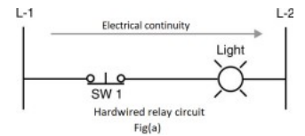

Fig (a), shows electrical continuity when SW 1 is closed, as the current flows from L-1 to L-2 energizing the load. Even though PLC ladder logic was modelled after the conventional relay ladder, there is no electrical continuity in PLC ladder logic. PLC ladder rungs should have logical continuity in order for the output to energize. PLC ladder program uses familiar terms like "rungs" and "normally open" and "normally closed" contacts, but the relay ladder logic has no electrical continuity between an input and the controlled output. Each rung in a ladder diagram is a program statement. This program statement consists of a condition or sometimes conditions, along with some type of action. Inputs are the conditions, and the action, or output, is the result of the conditions.

As in case of physical wiring hardware devices connected in series or parallel, PLC also combines ladder program instructions in series or parallel. However, rather than working in series or parallel, the PLC combines instructions logically using logic operators. Logical operations performed by PLC are nothing but fundamental logic operation, using fundamental logic operators like: AND, OR, and NOT. These operators are used to combine the instructions on a PLC rung so as to make the outcome of each rung either true or false.

**a) The AND-logic function:**

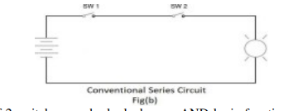

The series circuit of 2 switches can be looked as an AND logic function. In fig (b) and fig (c), both switch1 and switch2, must be closed to have electrical continuity. When there is electrical continuity, output (light1) will energize. Hence the keyword here is AND

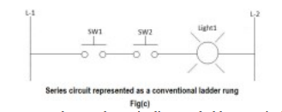

The circuit in fig (b) is represented as a schematic diagram ladder rung in fig (c). When the switch1 and switch2 is closed, electrical continuity is established to L-2. This is shown in fig (d).

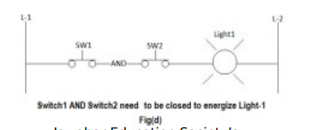

The various possible switch combinations are shown in the truth table below.

Table 1: Truth table for AND logic

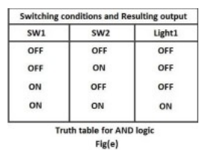

Fig (d) can be written in PLC ladder format as shown in the figure below

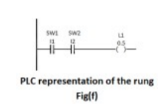

Here is the program listing for a typical PLC, if you are entering the program with a handheld programmer. LOAD I1 AND I2 OUT O5 The above instruction tell the processor to load input 1 (I1) into memory, AND it with input 2 (I2) and then output the result to output 5 (O5). The resulting output will be based on the truth table fig (e).

**b) The OR-logic function:**

In an OR - LOGIC function, the output is true if any input is true. The OR logic also states that if all inputs are true, the output will be true.

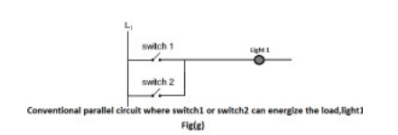

In the above figure, if switch1 OR switch2 is energized then light1 will energize. Also, if both SW 1 and SW2 are true, the output will also be true.

Fig (g) is converted to PLC ladder rung and it looks like fig (h)

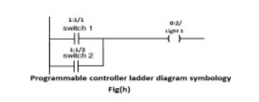

A PLC rung of logic will have normally open or normally closed contacts instead of normally open or normally closed switch symbols. Addresses and instructions are included. Here, in additions to each contact and its address, text information such as SW1, SW2 and L-1 is used and they are referred to as instruction comments. These instruction comments can be added from programming software.

Table 2: Truth table representing two-input OR function

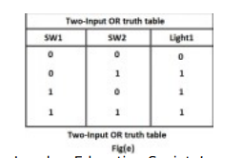

**c) The NOT-logic function:**

A normally closed relay contact passes power any time when the relay coil is not energized. In the same manner, the normally closed PLC ladder logic instruction will pass power any time when the input status file bit associated is not a 1. In this condition, the physical hardware input is not sending an input signal into the PLC's input module. The opposite of normally open PLC instruction or contact is the NOT logic. NOT logic can be used in conjunction with AND or OR logic, when a logical 0 in the status file is expected to activate some output device. In other words, NOT logic is used when an input is not energized i.e., 0 in the associated status bit, the output should be energized. Also, when the input is energized i.e., 1 in the associated status bit, the output should not be energized.

Table 3: Truth table for NOT function

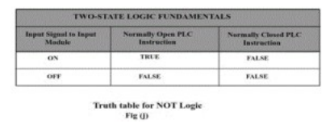

**2 Analysis**:

2.1) Analysis of rung 1: When I1 is true i.e. the input status file bit regarding I1 is true (1), the instruction I1 will energize the output. The instruction I1 is considered true when it passes logical continuity. If there is no valid input signal from the field input devices attached to I1's screw terminal on the input module, a logical 0 will be placed in the associated input status file bit. A logical 0 in the input status file will make the normally open input instruction to become false .When normally open instruction is false, it will not pass logical continuity.

2.2) Analysis of rung 2: The normally closed instruction works much like normally closed contacts on a hardware relay. In the fig (k), when the normally closed instruction I2 is true, i.e. the associated status file bit has a valid zero (0), logical continuity is established to energize the output. When the associated status file bit has valid 1, the NC instruction goes false and there is no logical continuity and the output is not energized.

a) The PARALLEL NOT- logic function:

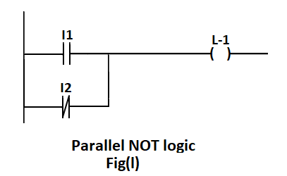

PLC ladder rung has 2 input instructions, one normally open and the other one is normally closed. This circuit contains parallel NOT logic. This schematic rung will be true under the conditions shown in the truth table below.

Table 4: Input and output relation of a parallel NOT function. Output L-1 will be energized only when input1 must be true OR input2 must not be true

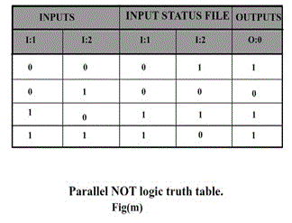

b) The EXCLUSIVE OR-logic function:

Table 5: Input and output relation of an exclusive OR function.

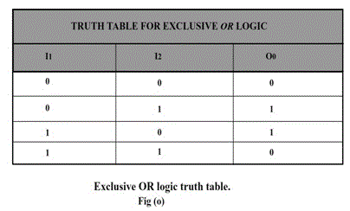

Ladder rung of EXOR GATE would look like this

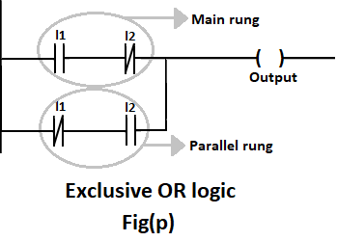

**Case 1**

When I1 = 0 and I2 = 0 : Let us analyze main rung. When I1 = 0, the normally open instruction is false and, normally closed instruction is true, but since normally open instruction is false, there is no logical continuity and output cannot be energized. Similar analysis can be done in parallel rung, normally closed instruction will be true and normally open instruction will be false and output is not energized.

**Case 2**

When I1= 0 and I2 = 1: In main rung, normally open instruction will be false and, normally closed instruction will be true, but since there is no logical continuity this rung logic cannot energize the output. But, in parallel rung, normally closed instruction will be true, as well as normally open instruction will also be true, hence there is logical continuity, and output is energized.

**Case 3** When I1 = 1 and I2 = 0: This case is similar to case 2, only the role of inputs are interchanged i.e. here main rung is true and energizes the output and parallel rung is false**.**

**Case 4** When both inputs are true, the main ladder rung as well as the parallel ladder rung goes false. In main rung, normally open instruction is true but normally closed instruction is false. Hence, there is no logical continuity. In parallel ladder rung, normally closed instruction is false and normally open instruction is true, and here also there is no logical continuity. Hence, the output is not energized.

**Procedure**: Apparatus required: Power supplies (for PLC, light/load), two switches, PLC, programmer (programming device). Steps to be followed:

* Step 1: To connect the switches to the corresponding input screw terminal and light to the corresponding output screw terminal.
* Step 2: To develop ladder logic that implements the required logic function.
* Step 3: To download the logic into the PLC memory.
* Step 4: Verify its truthfulness, by changing the switch conditions and observe the behaviour of the output.

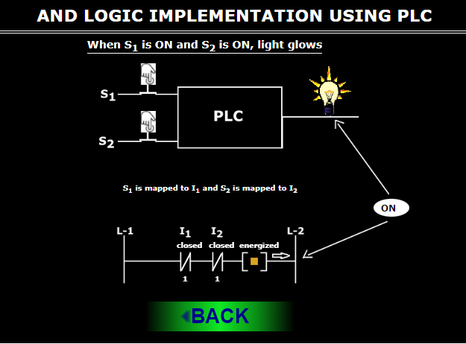**Result:**

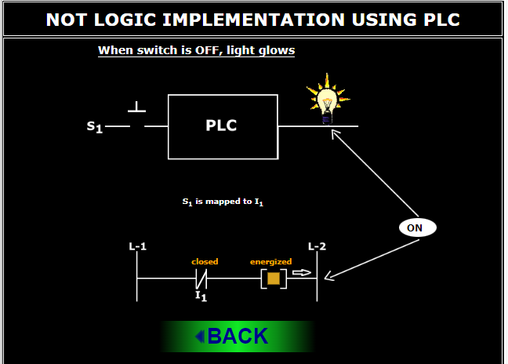

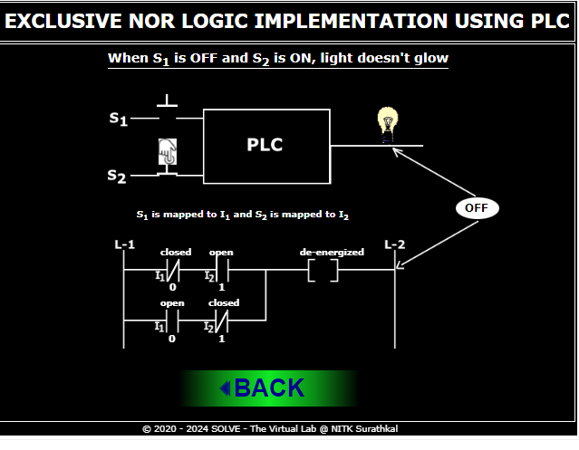

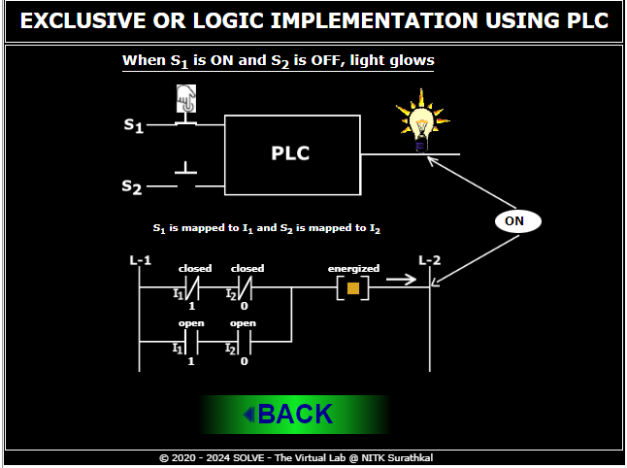

**Conclusion:**

The study of Programmable Logic Controller (PLC) basics, programming elements, and their operation for Ladder Diagrams in the Industrial Internet of Things (IIoT) offers invaluable insights into the heart of modern industrial automation.

**EXPERMINT: 08**

⚫ **Title** Container filling process using a programmable logic controller.

⚫ **Aim:** To study and simulate Container filling process using a programmable logic controller.

⚫**Theory:**

**Introduction**

In order to understand, the container filling process, we need certain instrument like Motor, Conveyor, Solenoid valve, level sensor, proximity sensor, LED's, push button and Programmable Logic Controller.

**Motor**:

Motor is required to produce the torque and power required to pull the conveyor.

**Level Sensor:**

Level sensors are used to detect the level of substances that flow, which include liquids, slurries, granular materials etc. The substance which is being measured can be inside a container or can be in its natural form (e.g. a river or a lake). The measurement of level can be either continuous or point values. Continuous level sensors measure level within a specified range and determine the exact amount of substance in a certain place, while point-level sensors only indicate whether the substance is above or below the sensing point.

The selection criteria include the physical phase (liquid, solid or slurry), temperature, pressure or vacuum, chemistry, dielectric constant of the medium, specific gravity of the medium etc.

Sensors which are available for point level detection of solids are:

* Vibrating point
* Rotating paddle
* Admittance type

Sensors which are available for point level detection of solids are:

* Pulse-Wave ultrasonic(Non Invasive):
* Magnetic and mechanical float
* Pneumatic
* Conductive

Sensor for both point level detection and continuous monitoring of solids and liquids:

* Ultrasonic
* Capacitance
* Optical interface
* Microwave

Sensors for continuous level measurement of liquids:

* Magnetostrictive
* Resistive chain
* Hydrostatic pressure
* Air bubbler
* Gamma rays

For our experiment Point level detection of liquids is concerned.

**Proximity sensor:**

A proximity sensor is a sensor able to detect the presence of nearby objects without any physical contact.

A proximity sensor often emits an electromagnetic field or a beam of electromagnetic radiation (infrared, for instance), and looks for changes in the field or return signal. The object being sensed is often referred to as the proximity sensor's target. Different proximity sensor targets demand different sensors. For example, a capacitive photoelectric sensor might be suitable for a plastic target; an inductive proximity sensor always requires a metal target.

The maximum distance that this sensor can detect is defined "nominal range". Some sensors have adjustments of the nominal range or means to report a graduated detection distance.

Proximity sensors can have a high reliability and long functional life because of the absence of mechanical parts and lack of physical contact between sensor and the sensed object.

**Conveyor system:**

A conveyor system is a common piece of mechanical handling equipment that moves materials from one location to another. Conveyors are especially useful in applications involving the transportation of heavy or bulky materials. Conveyor systems allow quick and efficient transportation for a wide variety of materials, which make them very popular in the material handling and packaging industries. Many kinds of conveying systems are available, and are used according to the various needs of different industries.

**Push button :**

Push button is a kind of a switch which is activated or deactivated the moment we press or depress it. It sends a signal momentarily when we press or depress it.

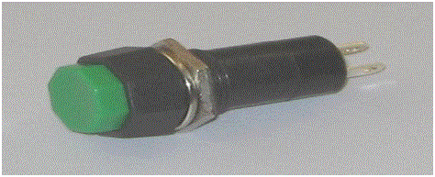

Solenoid valve :

A solenoid valve is an electromechanical device used for controlling gas or liquid flow.

What are the different parts of solenoid?

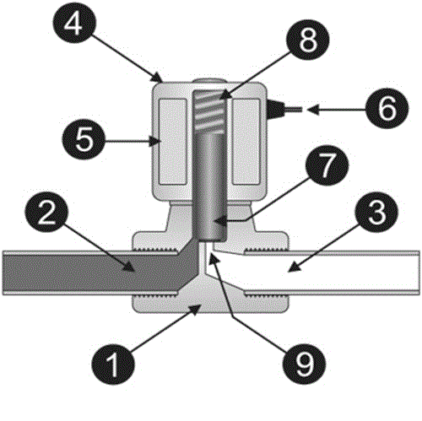

In the above figure,

* Valve body
* Inlet port
* Output port
* Coil/solenoid
* Coil winding
* Lead wires
* Plunger
* Spring
* Orifice

The above figure shows the basic components of a solenoid valve. The above picture represents a normally-closed, direct-acting valve. This type of solenoid valve has the most simple and easy to understand principle of operation.

**Let us see its working :**

The media enters the solenoid valve through inlet port and must flow through the orifice before continuing into the outlet port. The orifice is closed and opened by the plunger.

The valve pictured above is normally-closed solenoid valve. Normally-closed valve use a spring which presses the plunger tip against the opening of the orifice. The sealing material at the tip of the plunger keeps the media from entering the orifice, until the plunger is lifted up by an electromagnetic field created by the coil.

**Procedure** :

Procedure : In our experiment, we wish to have a container filling process using a programmable logic controller.

Let us see its basic diagram:

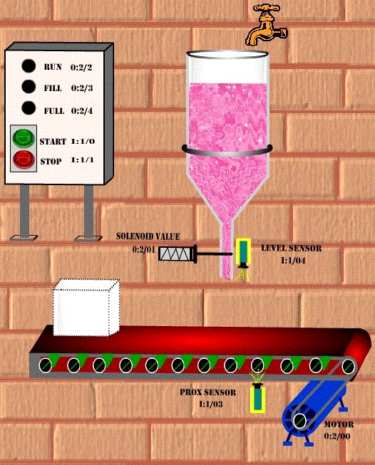

Since the inputs and outputs to the PLC are less, 8-point input module and 8-point output modules is sufficient, where CPU resides in slot 0, input module resides in slot and output module in slot 2.and output signal.

Let us assign address for the input and output signals of the PLC:

* Start (Normally open push button) : I:1/0
* Stop (Normally closed push button) :I:1/1
* MOTOR: O:2/0
* SOLENOID VALUE : O:2/1
* RUN (LED) : O:2/2
* FILL (LED) : O:2/3
* FULL (LED) : O:2/4
* PROX SENSOR(Proximity sensor) : I:1/3
* LEVEL SENSOR(Level sensor) : I:1/4

Let us see its ladder logic diagram:

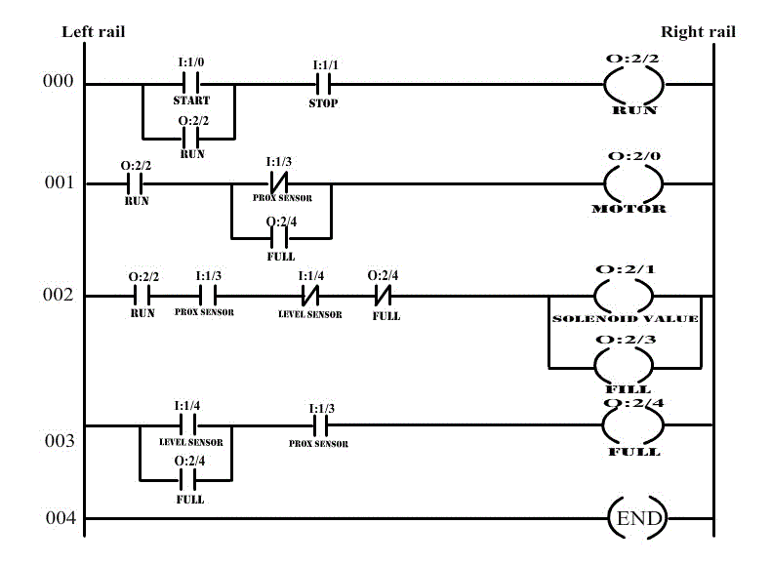

* Here, when the start push button is pressed, Container filling process gets started (motor is turned on) and RUN LED will glow. When the container reaches the filling position, proximity sensor (PROX SENSOR) senses its position and motor is stopped and solenoid valve will open. So the container starts filling till the container gets filled. During this time, FILL LED will glow. Once the container gets filled, completely, level sensor will sense the maximum limit and solenoid valve is closed. During this time, FULL LED will glow. Now, motor is started and container moves over the conveyor. This process is continuously executed.
* In order to understand the working of container filling process, click the start and stop push buttons and observe the ladder diagram and LED’s correspondingly

The following screen shot explains the operation:

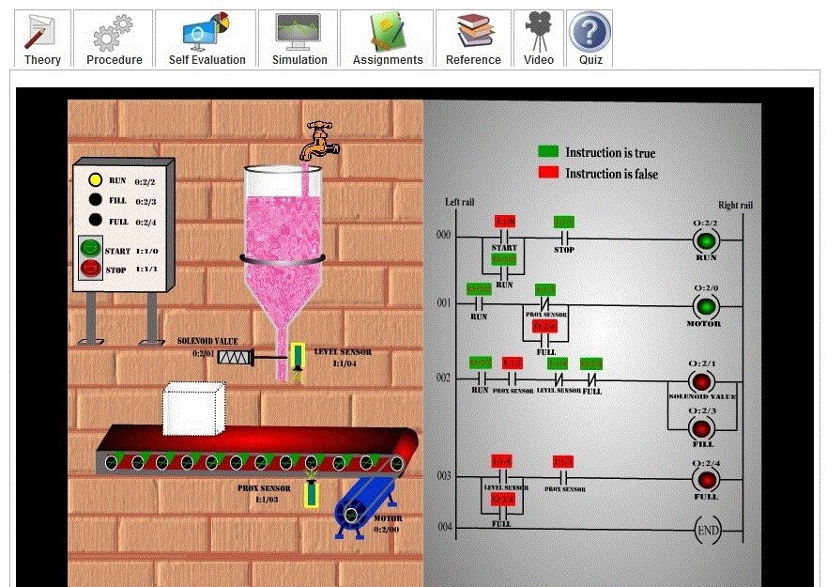

The above screen shot shows the condition before the current-batch container gets filled.

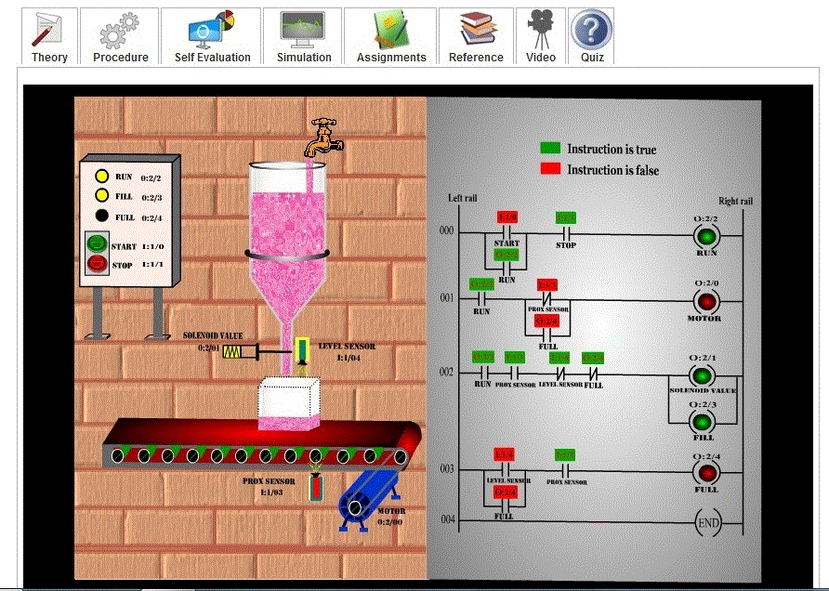

The above screen shot represents the condition when the current-batch container is getting filled.

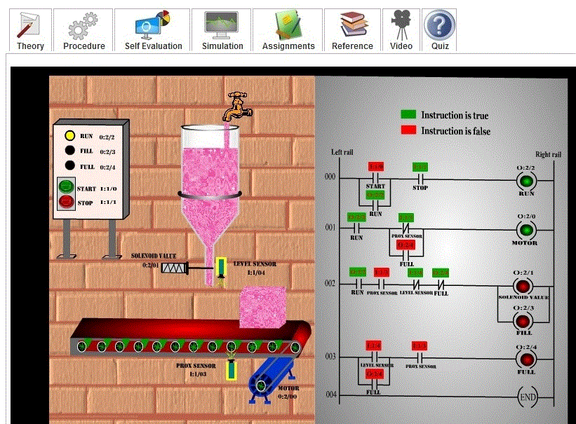

The above screen shot shows the condition after the current-batch container gets filled and before the start of next batch.

**Result:**

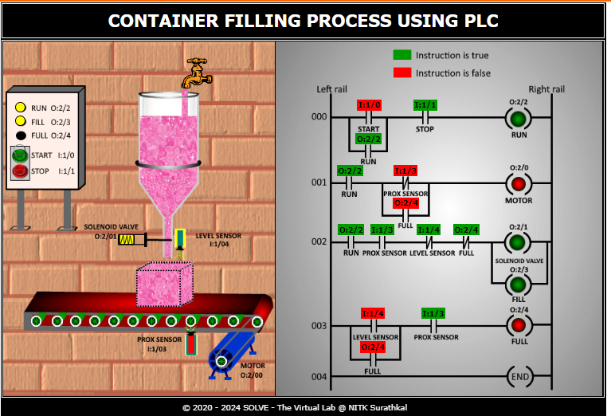

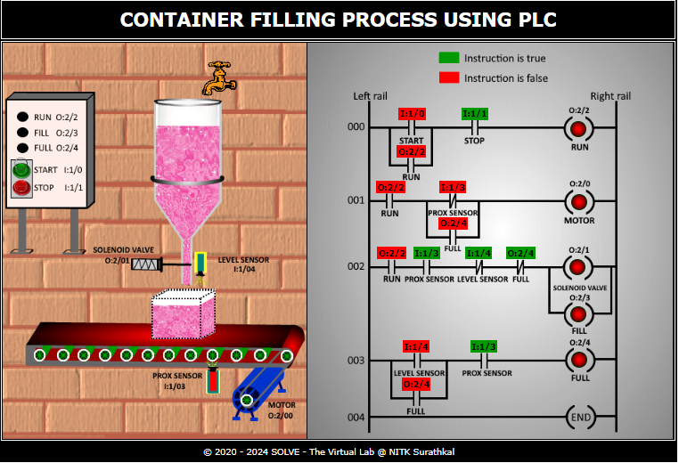

**Conclusion:**

**T**he study and simulation of container filling processes using a programmable logic controller (PLC) present a promising avenue for optimizing industrial manufacturing operations. Through the utilization of PLCs, which offer flexibility, precision, and automation capabilities, manufacturers can enhance efficiency, accuracy, and safety in container filling operations.

**EXPERMINT: 09**

⚫ **Title**: The working of Garage Programmable Logic Controller.

⚫ **Aim:** To understand the working of Garage shutter opening and closing using PLC.

⚫**Theory:**

**Introduction**

In order for the garage shutter to open or close , we need certain instruments like motor, coupling, gear box, shaft, limit switches ,chain or belt ,light emitting diode(LED),push buttons (N.O and N.C) and PLC.

Let us see some of the instruments used in detail:

**Motor :**

Motor is required to produce the torque and power required to pull the garage shutter. For this purpose we can make use of either DC or AC motor. As the speed with which the garage shutter door is opened is preferably constant, we can make use of AC motor. A single phase AC motor, which is also known as general purpose motor would be sufficient.

**Coupling :**

A coupling is a device used to connect two shafts together at their ends for the purpose of transmitting power. Here in our case , we are using to connect shaft of the motor to gear box.

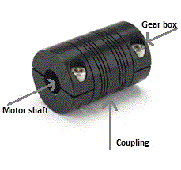

**Gear box :**

Gear box is a device that uses gears and gear trains to provide speed and torque conversions from a rotating power source to another device. In simple words it can be used to increase or decrease speed or decrease or increase torque.

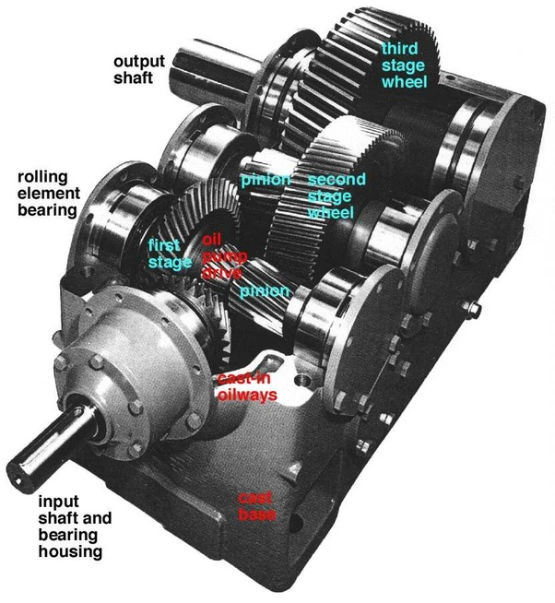

**Light emitting diode :**

Light emitting diodes are used to indicate the states of the garage shutter, whether it is closed, opened or in between.

**Limit switch :**

A limit switch is a type of switch used to stop the motion of a machine slide (or in our case garage door) or element once it reaches a fixed point.

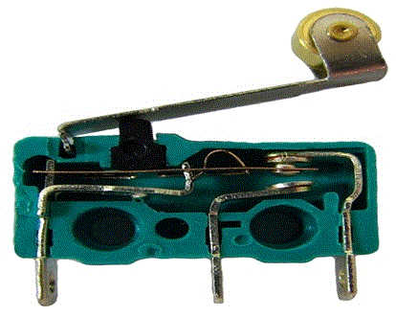

**Working of a limit switch :**

The basic limit switch has a spring-loaded push button connected to an electric circuit. When the push button (actuator) is pushed inside it trips or actuates the electrical circuit. The electrical circuit then signals a machine element to stop or start its motion. Once the pressure on the push button is removed, it comes back to its original position and is ready for the next cycle.

**Selection of limit switch :**

Limit switches are classified based on their actuating mechanism and application. The types of limit switches are many and some of them are: - linear limit switch, programmable limit switch, plunger limit switch, limit micro switch etc. Other types of limit switches are called optical proximity switches or magnetic proximity switches. Optical proximity switches utilize two different components. One component emits an infra-red light beam to a receiver mounted at a straight distance away. If the light beam is broken, the optical proximity limit switch will open, “turn off" or close, “turn on" a circuit to switch the electrical power. A magnetic proximity limit switch is a singular device that will also turn on or turn off when it comes close to a piece of metal. Regardless of the types or sizes of limit switches, these devices can only accomplish a task of a activation or deactivation.

**Application** :

Limit switches are very commonly used devices. For example :

* Turning OFF of the light, when the refrigerator door is closed.
* Switching ON of car's dome lights when we open the door.
* Stopping of the washing machine when load becomes unbalanced.
* Limit switch are also used in scissor lifts, conveyor systems, transfer machines, material packing and handling equipment, elevators, escalators, general safety equipment etc.

**Push button :**

Push button is a kind of a switch which is activated or deactivated the moment we press or depress it. It sends a signals momentarily when we press or depress it.

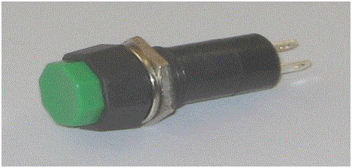

**Procedure :**

Procedure : For the purpose of opening and closing of garage door shutter, we need motor, limit switch, push button, coupling, light emitting diode, shaft and gear box.

Let us see the basic diagram of the circuitry.

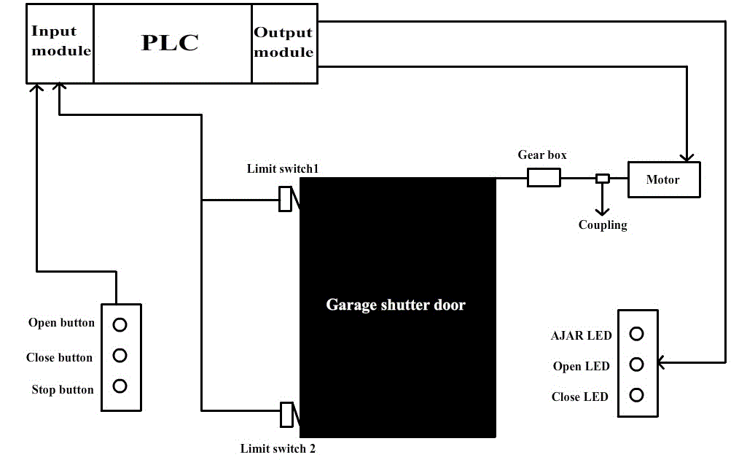

The PLC is used here to take input from the user, whether to open door, close door or just stop either of the action .It gives signal to the motor to open or close the shutter accordingly. Limit switches are used to determine the extreme position of garage shutter. This signal is a form of input to the PLC. Limit switch1 is used to identify the upper limit of the garage shutter i.e. when garage shutter is fully open. Limit switch2 is used to identify the lower limit of the garage shutter i.e. when garage shutter is fully closed.

**Steps to design the process :**

* Choose a shaft of proper strength to withstand the weight of the garage shutter and notice its diameter.
* Calculate the torque required to pull the garage shutter.
* Calculate the torque of the motor used to pull the garage shutter.
* Use the equation,
* Motor torque * gear ratio = Torque to pull garage shutter--(1)
* Find the required Gear ratio from the above equation.
* Design the required ladder logic for the process.

**Design specification :**

* Assuming we have a garage shutter of 9*9 feet and weighing about 100 kg. Also, taking 1.5kw *2800 rpm synchronous ac motor.
* Torque required to pull the garage shutter

Assuming the shaft to be of 2.4cm diameter , or radius of 1.2cm.

We know, Torque = Force*distance,

= (Mass*acceleration)*distance

= (100kg*10m/s2)*(1.2*10-2m)

Torque = 12 N-m

Torque produced by motor

Torque of motor = {Power (kW)*60000} / {2*3.14*rpm}

= (1.5*60000)/ (2*3.14*2800)

Torque of motor = 5.118 N-m

**Ladder logic design**

Now, let us see how the ladder logic of the garage shutter (shown below) is implemented in a PLC.

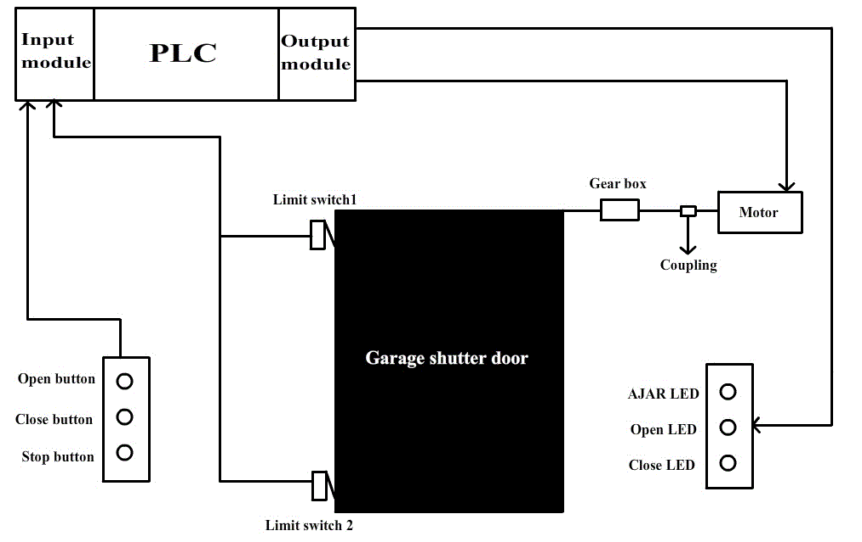

**Our assumption:**

* Open push button used is normally open, close push button used is normally open and stop push button used is normally closed.
* Limit switch1 (LS1): not activated (false) when door is fully opened, else activated (true).
* Limit switch2 (LS2): activated (true) when door is fully closed, else not activated (false).
* Since inputs and outputs are less, 8-point I/O module PLC is sufficient, where CPU resides in slot 0, input module resides in slot1, and output module resides in slot2.
* Let us assign address for the input and output signals of the PLC.
* Open(push button): I:1/0
* Close(push button): I:1/1
* Stop(push button): I:1/2
* LS1: I:1/3
* LS2: I:1/4
* Motor up : O:2/0
* Motor down: O:2/1
* AJAR LED: O:2/2
* Open LED: O:2/
* Shut LED: O:2/4

**Let us see its ladder logic program:**

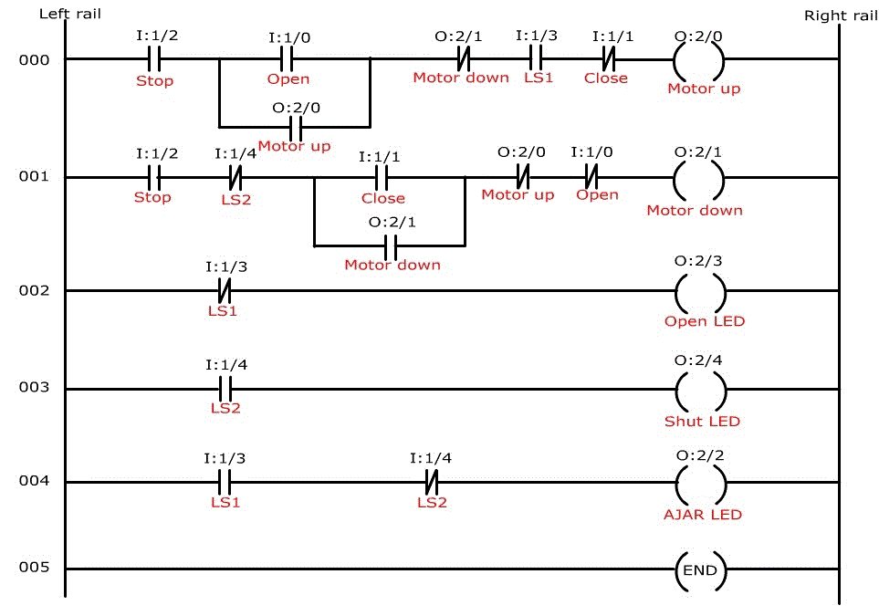

The above ladder logic program has 5 rungs , let us see the functions of each rung individually:

**Rung 000 :**

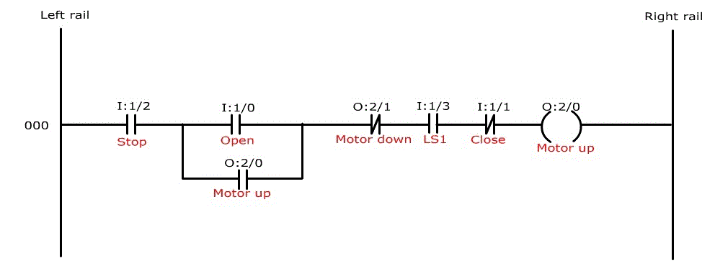

The above rung is used to open the garage shutter. The above rung passes logical continuity, when open push button is pressed. It will pass logical continuity as long as stop or close push button is not pressed. It will pass logical continuity as long as door is not fully opened. The moment door is fully opened the motor is de-energized. Since open switch used is a push button, it has to be latched.

**Rung 001 :**

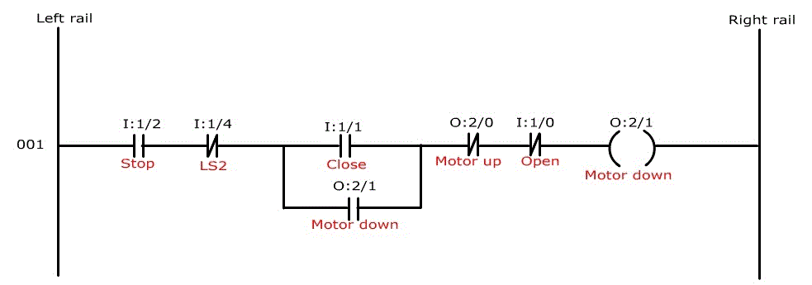

The above rung is used to close the garage shutter. The above rung passes logical continuity, when close push button is pressed. It will pass logical continuity as long as stop or open push button is not pressed. It will pass logical continuity as long as door is not fully closed. The moment door is fully closed the motor is de-energized. Since close switch used is a push button, it has to be latched.

**Rung 002 :**

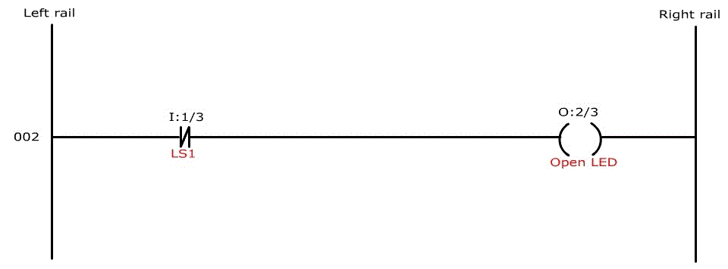

The above rung is used to indicate open condition of the garage shutter. When the garage shutter is fully opened, the signal from the Limit switch1 (LS1) is false i.e. 0 is sent to the corresponding input status file i.e. input screw terminal 3, has 0 in its corresponding input status file bit location. Thus open LED will be energized.

**Rung 003 :**

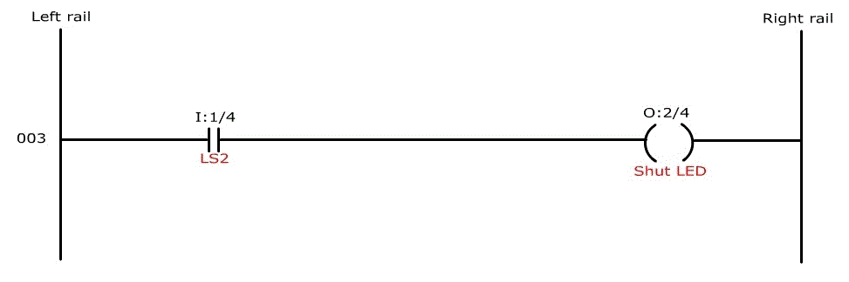

The above rung is used to indicate shut condition of the garage shutter. When the garage shutter is fully closed, the signal from the Limit switch2 (LS2) is true i.e. 1 is sent to the corresponding input status file i.e. input screw terminal 4, has 1 in its corresponding input status file bit location. Thus shut LED will be energized.

**Rung 004 :**

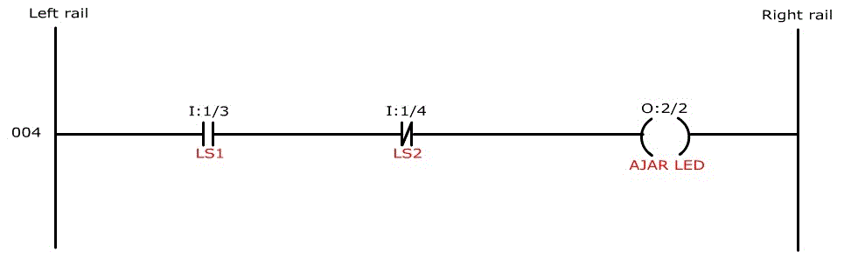

AJAR LED is used to indicate that the garage shutter is not in its extreme positions i.e. it is not completely closed or completely open. In other words, it is in between of two extreme positions. When the garage shutter is fully opened, the signal from the Limit switch1 (LS1) is false i.e. 0 is sent to the corresponding input status file i.e. input screw terminal 3, has 0 in its corresponding input status file bit location. Hence, the normally open instruction becomes false and logical continuity is lost. As a result AJAR LED is de-energized. When the garage shutter is fully closed, the signal from the Limit switch2 (LS2) is true i.e. 1 is sent to the corresponding input status file i.e. input screw terminal 4, has 1 in its corresponding input status file bit location. Hence, the normally closed instruction becomes false and logical continuity is lost. As a result AJAR LED is de-energized. So, only when the garage shutter is in between of the two extreme positions, logical continuity is passed and AJAR LED is energized.

**Result**:

**The following screen shots represents the operation:**

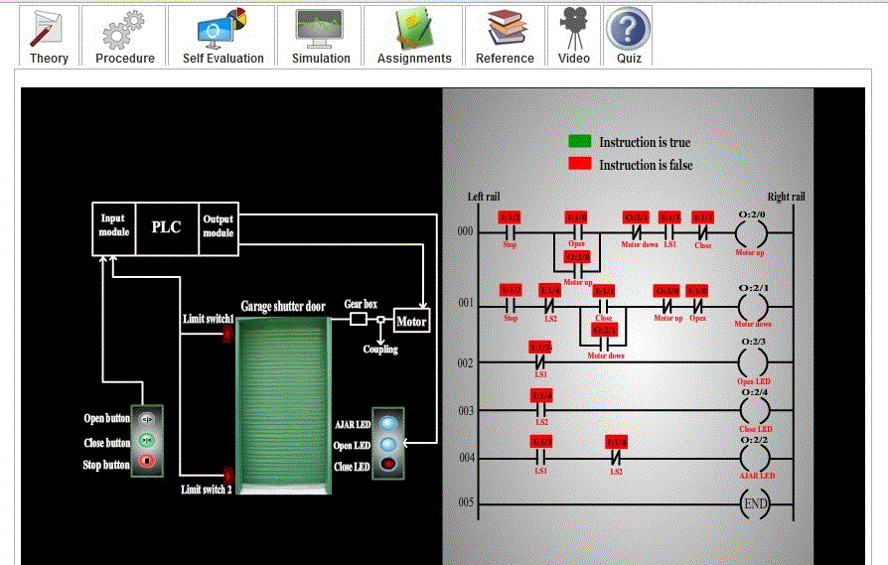

The above screen shot represents the condition when the Garage shutter is completely closed.

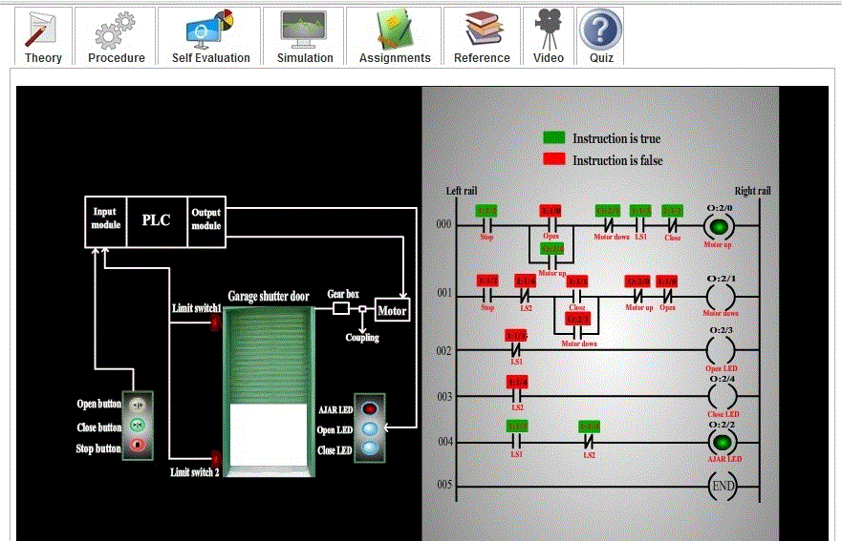

The above screen shot represents the condition when the Garage shutter is in intermediate stage i.e. can be opening or closing.

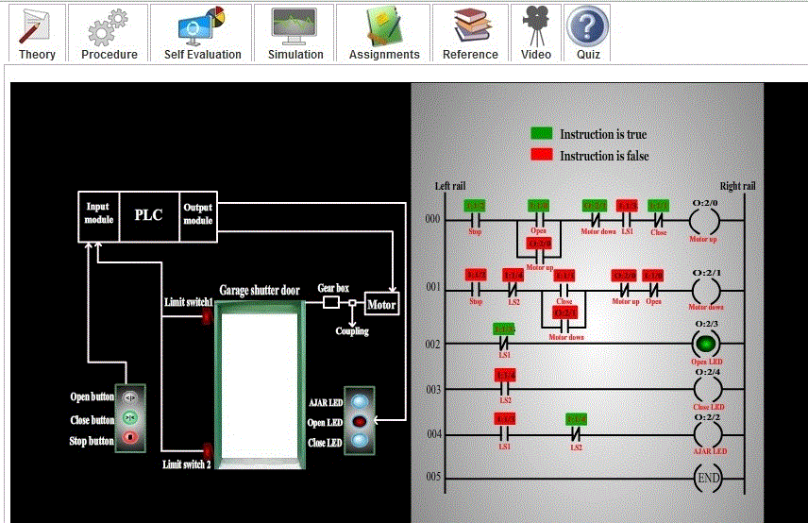

**Conclusion:**

The project aimed to explore the functionality of garage shutter opening and closing using Programmable Logic Controller (PLC) technology. Through the implementation of PLC-based automation, we sought to achieve efficient, reliable, and safe operation of garage shutters, enhancing convenience and security for users.

**EXPERMINT: 10**

⚫ **Title**: Case study which will be a solution to a real problem.

⚫ **Aim:** Case study which will be a solution to a real problem and can be eased with the use of automation and IOT. The sample case studies can be as follows:

● Smart agriculture System.

⚫**Theory:**

Case Study: Smart Agriculture System for Crop Monitoring and Irrigation Management

**Problem Statement:**

Traditional agriculture practices often rely on manual labor and subjective decision-making, leading to inefficiencies in crop monitoring and irrigation management. Farmers face challenges such as water scarcity, unpredictable weather patterns, and labor shortages, resulting in reduced crop yields and financial losses.

**Solution**:

Implementing a Smart Agriculture System that integrates automation and IoT technologies can address these challenges and optimize crop monitoring and irrigation management. The system leverages sensors, actuators, data analytics, and communication technologies to provide real-time insights and automated control of irrigation systems.

**Key Components of the Smart Agriculture System:**

Sensor Network: Deploy various sensors across the farm to monitor environmental parameters such as soil moisture, temperature, humidity, and light intensity. These sensors collect data at regular intervals and transmit it wirelessly to a central control system.

Data Analytics Platform: Utilize cloud-based data analytics platforms to analyze the collected sensor data and generate actionable insights. Machine learning algorithms can predict crop water requirements, detect anomalies, and optimize irrigation scheduling based on historical data and weather forecasts.

Automated Irrigation Control: Integrate actuators and smart irrigation systems to automate the irrigation process. Based on the analyzed data and predefined thresholds, the system can automatically control irrigation valves to deliver the precise amount of water needed by each crop, optimizing water usage and minimizing waste.

Mobile Application: Develop a user-friendly mobile application that allows farmers to monitor their crops remotely, receive real-time alerts and notifications, and adjust irrigation settings as needed. The application provides insights into crop health, soil conditions, and irrigation status, empowering farmers to make informed decisions.

**Benefits of the Smart Agriculture System:**

Water Conservation: By precisely monitoring soil moisture levels and automating irrigation, the system reduces water consumption and minimizes water wastage, contributing to sustainable water management practices.

Increased Crop Yields: Optimized irrigation schedules and improved crop monitoring lead to healthier plants, higher yields, and better quality produce, enhancing farm profitability and food security.

Labor Savings: Automation of irrigation tasks reduces the need for manual labor, allowing farmers to allocate resources more efficiently and focus on other aspects of farm management.

Data-Driven Decision Making: Real-time monitoring and data analytics provide valuable insights into crop performance, enabling farmers to make data-driven decisions to optimize farming practices, mitigate risks, and maximize returns on investment.

**Conclusion:**

The implementation of a Smart Agriculture System offers a holistic solution to the challenges faced by traditional farming methods, promoting sustainable agriculture practices, improving productivity, and enhancing the livelihoods of farmers.